**Data analysis**

First of all, calculations of mean scores for both sets of dimensions were computed for each sample that had at least 20 responses (Central, North-Western, Southern, Volga, Ural, and Siberian federal districts) and appear in Table 3 and Table 4. Two federal districts, namely the North Caucasus (4 responses) and the Far East (6 responses), were excluded from the analysis due to the absence of a minimum designated threshold.

|  |  |  |  |  |  |  |  |  |  |  |  |
| --- | --- | --- | --- | --- | --- | --- | --- | --- | --- | --- | --- |
| Table 3. |  | | | Central FD | North-western FD | Southern FD | Volga FD | | Ural FD | | Siberian FD |
| Mean scores for the LBDQ dimensions for the samples | | Representation | | 3.58 | 3.70 | 3.81 | 3.82 | | 3.77 | | 3.67 |
| Demand Reconciliation | | 3.49 | 3.91 | 4.00 | 3.61 | | 3.75 | | 3.74 |
| Tolerance of Uncertainty | | 3.32 | 3.32 | 3.32 | 3.32 | | 3.32 | | 3.32 |
| Persuasiveness | | 3.82 | 3.82 | 3.82 | 3.82 | | 3.82 | | 3.82 |
| Initiation of Structure | | 3.86 | 3.86 | 3.86 | 3.86 | | 3.86 | | 3.86 |
| Tolerance of Freedom | | 3.60 | 3.60 | 3.60 | 3.60 | | 3.60 | | 3.60 |
| Role Assumption | | 3.39 | 3.39 | 3.39 | 3.39 | | 3.39 | | 3.39 |
| Consideration | | 3.65 | 3.77 | 3.87 | 3.76 | | 3.83 | | 3.86 |
| Production Emphasis | | 3.65 | 3.56 | 3.73 | 3.69 | | 3.71 | | 3.67 |
| Prediction Accuracy | | 3.72 | 3.96 | 3.84 | 3.78 | | 3.94 | | 3.84 |
| Integration | | 4.02 | 4.12 | 4.41 | 4.11 | | 4.27 | | 4.10 |
| Superior Orientation | | 3.84 | 3.98 | 3.90 | 3.91 | | 3.89 | | 3.78 |
|  | |  |  |  |  | |  | |  |
|  | Note(s): (Range: maximum 5, minimum 1) | | | | |  | |  | |

|  |  |  |  |  |  |  |  |  |
| --- | --- | --- | --- | --- | --- | --- | --- | --- |
| Table 4. |  | | Central FD | North Western FD | Southern FD | Volga FD | Ural FD | Siberian FD |
| Means scores for Hofstede’s Power Distance for the samples | | Power Distance | 39.49 | 38.60 | 32.17 | 37.03 | 40.00 | 44.39 |
| Individualism | 12.41 | 53.20 | 19.78 | 36.19 | 31.61 | 39.24 |
| Masculinity | 5.32 | -2.80 | 4.57 | 3.56 | 0.00 | 2.12 |
| Uncertainty Avoidance | -11.52 | -4.80 | -4.78 | -12.97 | -5.65 | 1.21 |
| Long-Term Orientation | 1.08 | -8.40 | 13.91 | 3.05 | 16.61 | 15.15 |
| Indulgence | 3.86 | 18.20 | 9.13 | 9.66 | 16.13 | 33.03 |
| Monumentalism | 27.22 | 44.60 | 57.83 | 38.05 | 67.10 | 31.21 |

Note(s): (raw, uncentered data was used, hence the negative values in some dimensions and samples)

To verify the relationship between the two concepts, the Pearson, Spearman as well as linear regression correlations were employed to assess the relationship between the aggregated sample mean values on the regional level of six federal districts between the two sets of dimensions. Thus, the following results were obtained:

**Representation**

Based on the given results, we can see that there are no significant or marginally significant correlations between Representation and all of Hofstede's cultural dimensions where the correlations are all weak and not significant, with P-values greater than 0.05. See table 5.

|  |  |  |  |  |
| --- | --- | --- | --- | --- |
| Table 5. |  | |  | Representation |
| Spearman and Pearson Correlations between means of Hofstede’s cultural dimensions and of LBDQ’s Representation in six Federal Districts | | Power Distance | Pearson’s r | -0.57 |
| P-value | 0.24 |
| Spearman’s rho | -0.66 |
| P-value | 0.16 |
| Individualism | Pearson’s r | 0.17 |
| P-value | 0.75 |
| Spearman’s rho | 0.09 |
| P-value | 0.87 |
|  | | Masculinity | Pearson’s r | -0.04 |
|  | | P-value | 0.93 |
|  | | Spearman’s rho | -0.09 |
|  | | P-value | 0.87 |
|  | | Uncertainty Avoidance | Pearson’s r | -0.09 |
|  | | P-value | 0.87 |
|  | | Spearman’s rho | -0.26 |
|  | | P-value | 0.62 |
|  | | Long-Term Orientation | Pearson’s r | 0.33 |
|  | | P-value | 0.52 |
|  | | Spearman’s rho | 0.20 |
|  | | P-value | 0.70 |
|  | | Indulgence | Pearson’s r | -0.09 |
|  | | P-value | 0.86 |
|  | | Spearman’s rho | -0.09 |
|  | | P-value | 0.87 |
|  | | Monumentalism | Pearson’s r | 0.66 |
|  | | P-value | 0.15 |
|  | | Spearman’s rho | 0.60 |
|  | | P-value | 0.21 |

Linear regression analysis was utilized for the samples as well as a visualization of the regression models was performed to better understand the results (see figures 1-7):

Figure 1. Representation and Power Distance

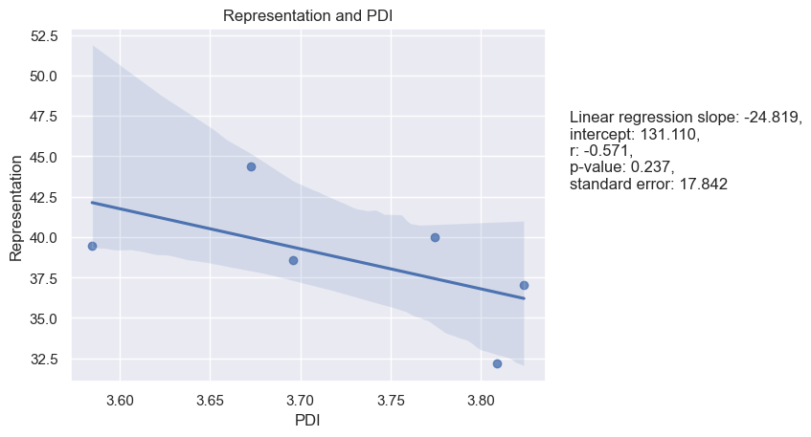

Figure 2. Representation and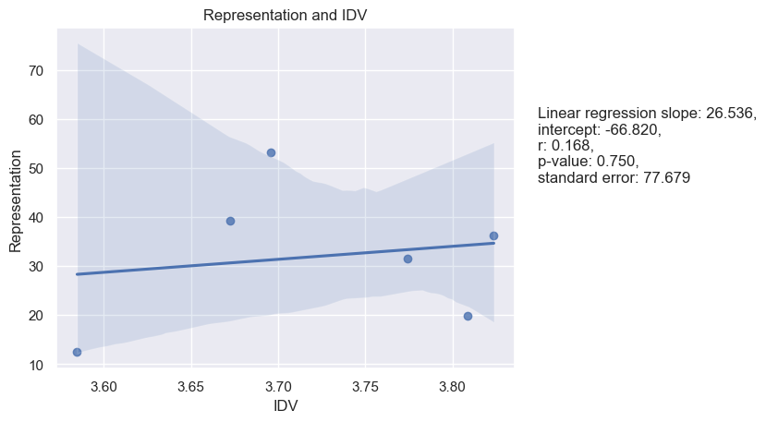 Individualism

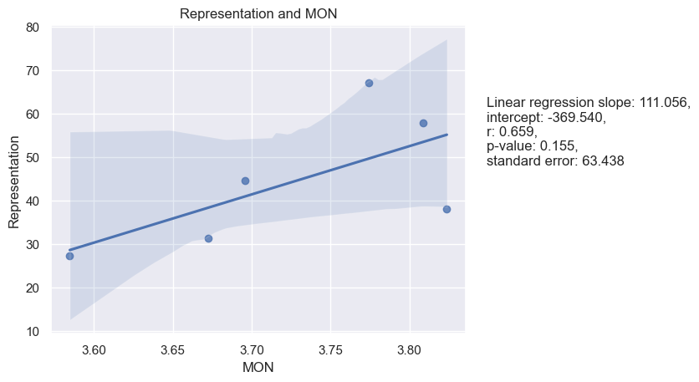

Figure 3. Representation and Masculinity

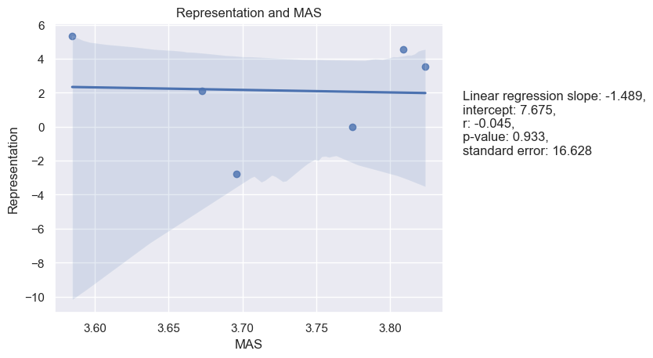

Figure 4. Representation and Uncertainty Avoidance

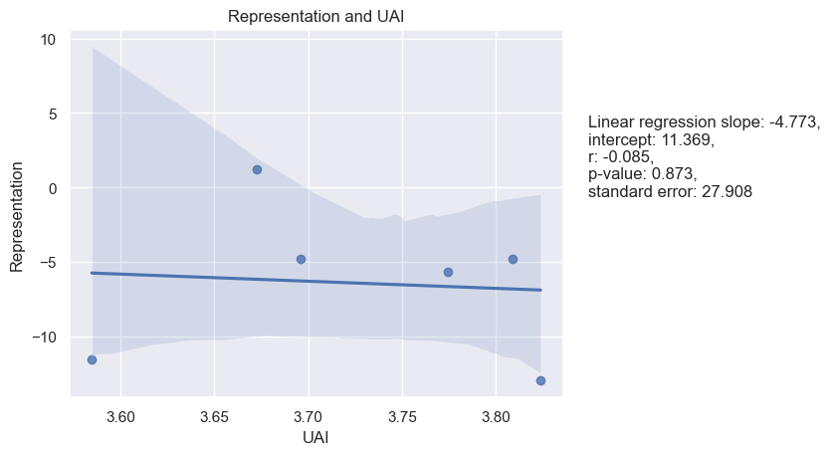

Figure 5. Representation and Long-Term Orientation

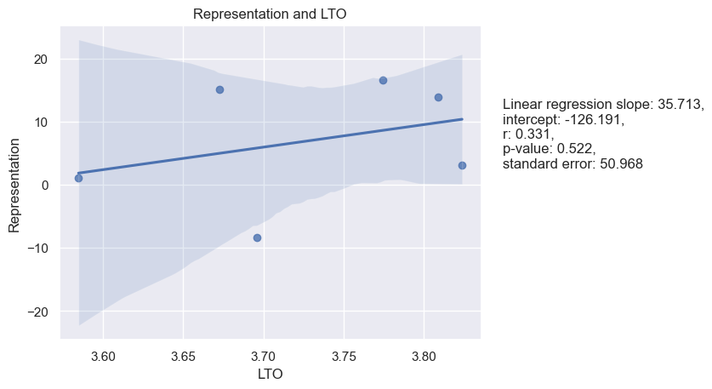

Figure 6. Representation and Indulgence

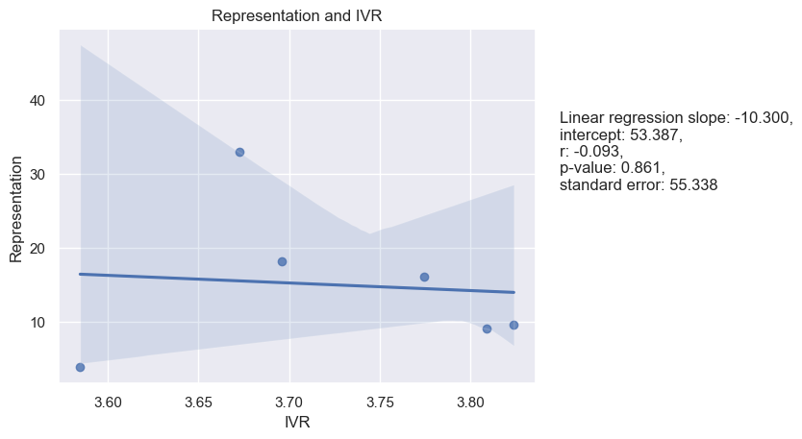

Figure 7. Representation and Monumentalism



**Reconciliation**

Based on several correlations and linear regressions conducted to analyze the relationship between the Reconciliation dimension of LBDQ and Hofstede's cultural dimensions, the only marginally significant correlation was between Reconciliation and UAI and Reconciliation and MON, with a Pearson correlation of 0.58 and a P-value of 0.23 and 0.62, a P-value of 0.19 accordingly. There were no significant correlations found with PDI, IDV, MAS, LTO, IVR, and MON. The linear regression analysis did not yield significant results either. See Table 6.

|  |  |  |  |  |
| --- | --- | --- | --- | --- |
| Table 6. |  | |  | Reconciliation |
| Spearman and Pearson Correlations between means of Hofstede’s cultural dimensions and of LBDQ’s Reconciliation in six Federal Districts | | Power Distance | Pearson’s r | -0.45 |
| P-value | 0.37 |
| Spearman’s rho | -0.37 |
| P-value | 0.47 |
| Individualism | Pearson’s r | 0.35 |
| P-value | 0.49 |
| Spearman’s rho | 0.26 |
| P-value | 0.62 |
|  | | Masculinity | Pearson’s r | -0.42 |
|  | | P-value | 0.40 |
|  | | Spearman’s rho | -0.43 |
|  | | P-value | 0.40 |
|  | | Uncertainty Avoidance | Pearson’s r | 0.58 |
|  | | P-value | 0.23 |
|  | | Spearman’s rho | 0.60 |
|  | | P-value | 0.21 |
|  | | Long-Term Orientation | Pearson’s r | 0.14 |
|  | | P-value | 0.80 |
|  | | Spearman’s rho | 0.14 |
|  | | P-value | 0.79 |
|  | | Indulgence | Pearson’s r | 0.26 |
|  | | P-value | 0.62 |
|  | | Spearman’s rho | 0.26 |
|  | | P-value | 0.62 |
|  | | Monumentalism | Pearson’s r | 0.62 |
|  | | P-value | 0.19 |
|  | | Spearman’s rho | 0.77 |
|  | | P-value | 0.07 |

Linear regression analysis and its visualization are presented below (see figures 8-14):

Figure 8. Reconciliation and Power Distance

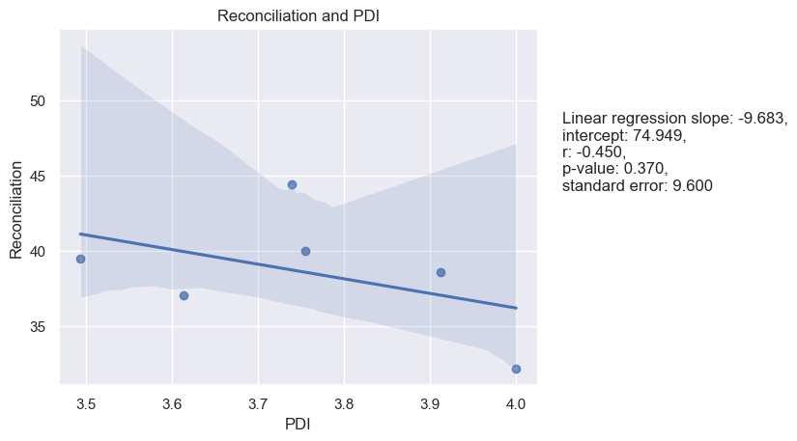

Figure 9. Reconciliation and Individualism

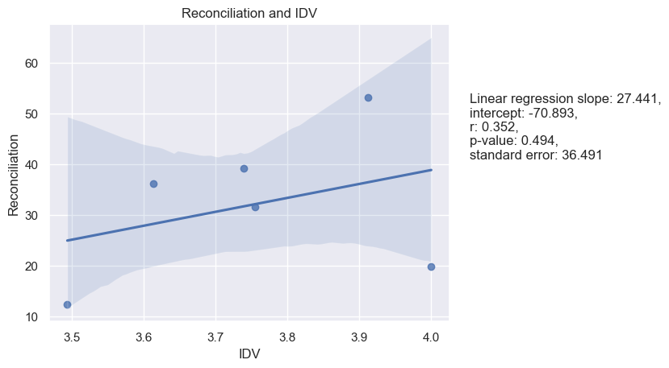

Figure 10. Reconciliation and Masculinity

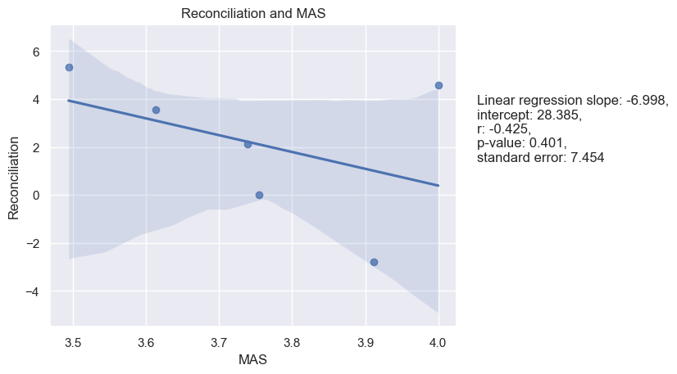

Figure 11. Reconciliation and Uncertainty Avoidance

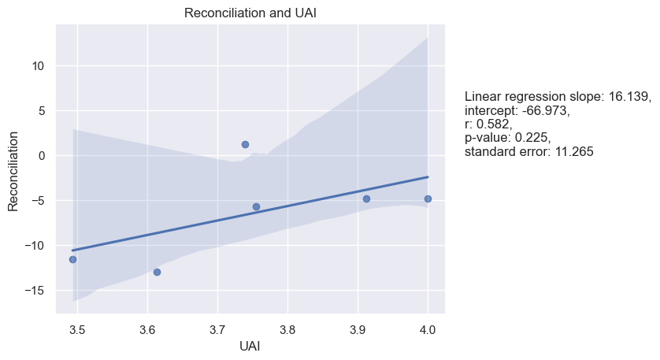

Figure 12. Reconciliation and Long-Term Orientation

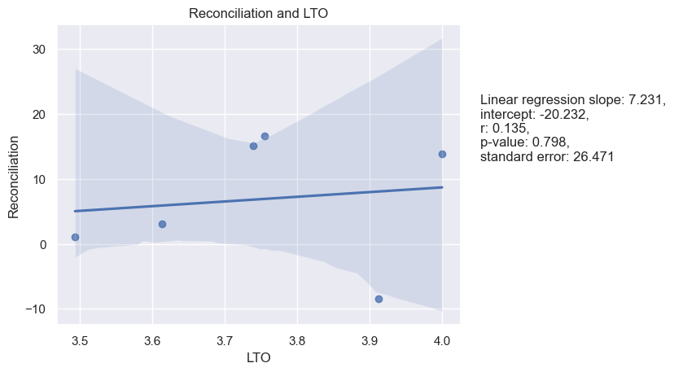

Figure 13. Reconciliation and Indulgence

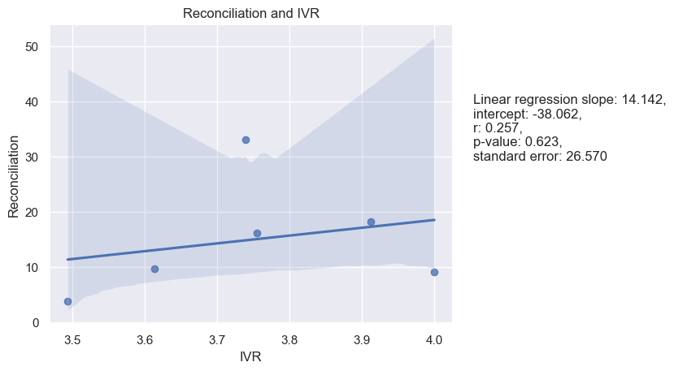

Figure 14. Reconciliation and Indulgence

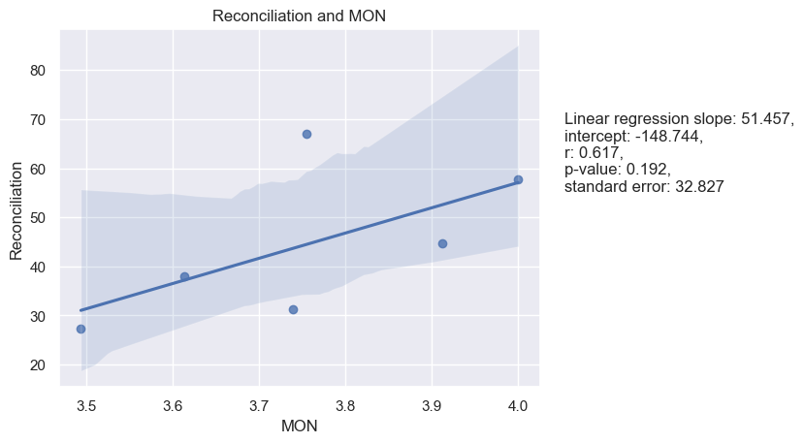

**Tolerance of Uncertainty and Hofstede’s dimensions**

There is a marginally significant negative correlation between Tolerance of Uncertainty and MAS with both Pearson and Spearman correlation coefficients are quite large (-0.82 and -0.71, respectively), indicating a strong negative correlation. This is also supported by the linear regression analysis, where the p-value (0.044) is less than 0.05. All other correlations are not significant, including those with PDI, IDV, UAI, LTO, IVR, and MON. See Table 7.

|  |  |  |  |  |
| --- | --- | --- | --- | --- |
| Table 7. |  | |  | Tolerance of Uncertainty |
| Spearman and Pearson Correlations between means of Hofstede’s cultural dimensions and of LBDQ’s Tolerance of Uncertainty in six Federal Districts | | Power Distance | Pearson’s r | -0.07 |
| P-value | 0.89 |
| Spearman’s rho | 0.09 |
| P-value | 0.87 |
| Individualism | Pearson’s r | 0.45 |
| P-value | 0.37 |
| Spearman’s rho | 0.37 |
| P-value | 0.47 |
|  | | Masculinity | Pearson’s r | -0.82 |
|  | | P-value | 0.04 |
|  | | Spearman’s rho | -0.71 |
|  | | P-value | 0.11 |
|  | | Uncertainty Avoidance | Pearson’s r | 0.27 |
|  | | P-value | 0.60 |
|  | | Spearman’s rho | 0.49 |
|  | | P-value | 0.33 |
|  | | Long-Term Orientation | Pearson’s r | -0.11 |
|  | | P-value | 0.83 |
|  | | Spearman’s rho | 0.03 |
|  | | P-value | 0.96 |
|  | | Indulgence | Pearson’s r | 0.11 |
|  | | P-value | 0.83 |
|  | | Spearman’s rho | 0.43 |
|  | | P-value | 0.40 |
|  | | Monumentalism | Pearson’s r | 0.72 |
|  | | P-value | 0.11 |
|  | | Spearman’s rho | 0.66 |
|  | | P-value | 0.16 |

Linear regression analysis was performed as well. See Figures 15-21:

Figure 15. Tolerance of Uncertainty and Power Distance

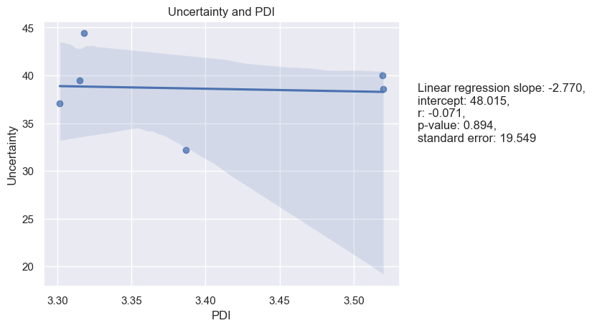

Figure 16. Tolerance of Uncertainty and Individualism

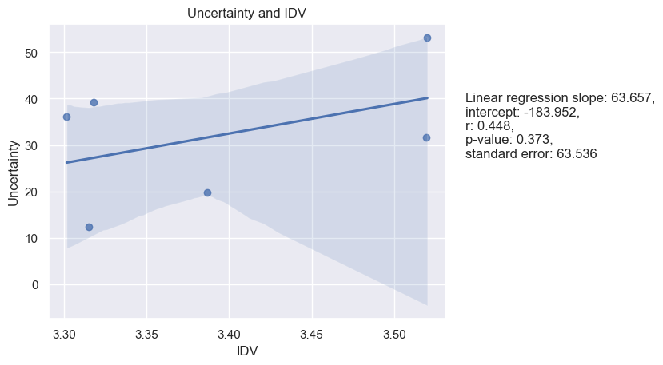

Figure 17. Tolerance of Uncertainty and Masculinity

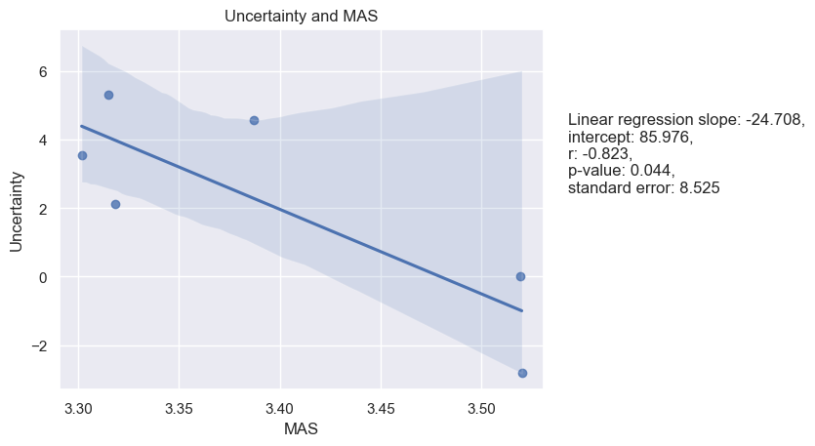

Figure 18. Tolerance of Uncertainty and Uncertainty Avoidance

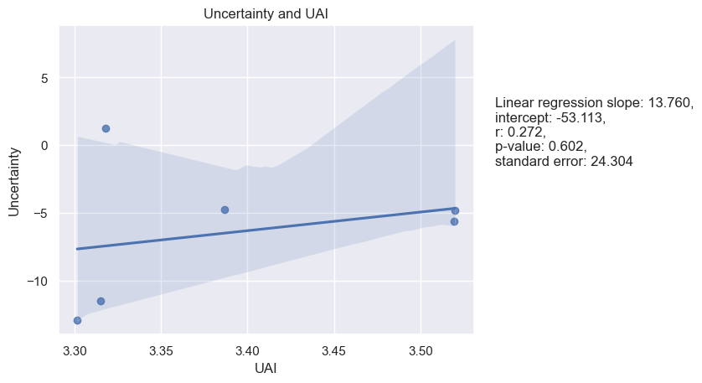

Figure 19. Tolerance of Uncertainty and Long-Term Orientation

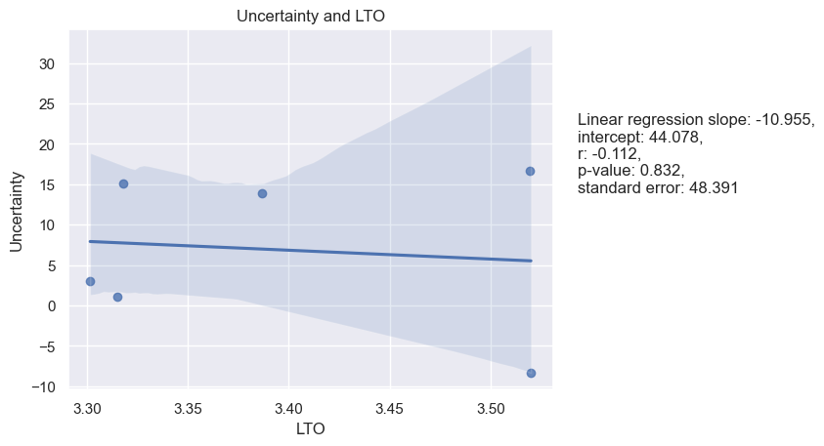

Figure 20. Tolerance of Uncertainty and Indulgence

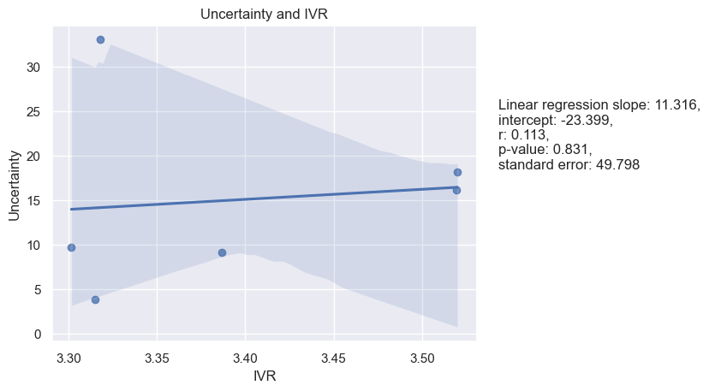

Figure 21. Tolerance of Uncertainty and Monumentalism

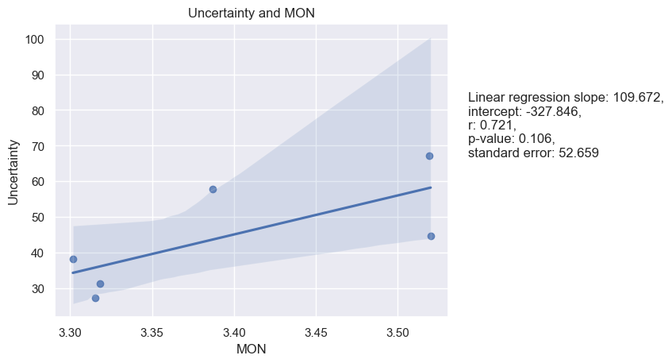

**Persuasiveness and Hofstede’s dimensions**

Based on the given results, the significant correlations observed are between Persuasiveness and MON, where both Pearson and Spearman correlations are relatively high, 0.76 and 0.89 respectively, with the linear regression analysis indicates a marginally significant p-value of 0.079, and between Persuasiveness and PDI, with a Pearson correlation coefficient of -0.81 and a p-value of 0.05. This means that as Persuasiveness increases, PDI tends to decrease. The linear regression model also shows a negative slope of -29.397, suggesting that for each unit increase in Persuasiveness, PDI decreases by 29.397, holding all other variables constant. For the other cultural dimensions, there is no significant correlation between Persuasiveness and PDI, IDV, MAS, UAI, LTO, and IVR, as the p-values for Pearson and Spearman correlations, as well as linear regression analyses are above the common threshold of 0.05. See Table 8.

|  |  |  |  |  |
| --- | --- | --- | --- | --- |
| Table 8. |  | |  | Persuasiveness |
| Spearman and Pearson Correlations between means of Hofstede’s cultural dimensions and of LBDQ’s Persuasiveness in six Federal Districts | | Power Distance | Pearson’s r | -0.81 |
| P-value | 0.05 |
| Spearman’s rho | -0.54 |
| P-value | 0.27 |
| Individualism | Pearson’s r | -0.21 |
| P-value | 0.68 |
| Spearman’s rho | -0.09 |
| P-value | 0.87 |
|  | | Masculinity | Pearson’s r | 0.16 |
|  | | P-value | 0.76 |
|  | | Spearman’s rho | -0.14 |
|  | | P-value | 0.79 |
|  | | Uncertainty Avoidance | Pearson’s r | 0.03 |
|  | | P-value | 0.95 |
|  | | Spearman’s rho | 0.09 |
|  | | P-value | 0.87 |
|  | | Long-Term Orientation | Pearson’s r | 0.44 |
|  | | P-value | 0.39 |
|  | | Spearman’s rho | 0.43 |
|  | | P-value | 0.40 |
|  | | Indulgence | Pearson’s r | -0.28 |
|  | | P-value | 0.59 |
|  | | Spearman’s rho | -0.09 |
|  | | P-value | 0.97 |
|  | | Monumentalism | Pearson’s r | 0.76 |
|  | | P-value | 0.08 |
|  | | Spearman’s rho | 0.89 |
|  | | P-value | 0.02 |

Linear regression analysis for the samples as well as a visualization of the regression models are presented below (see figures 22-28):

Figure 22. Persuasiveness and Power Distance

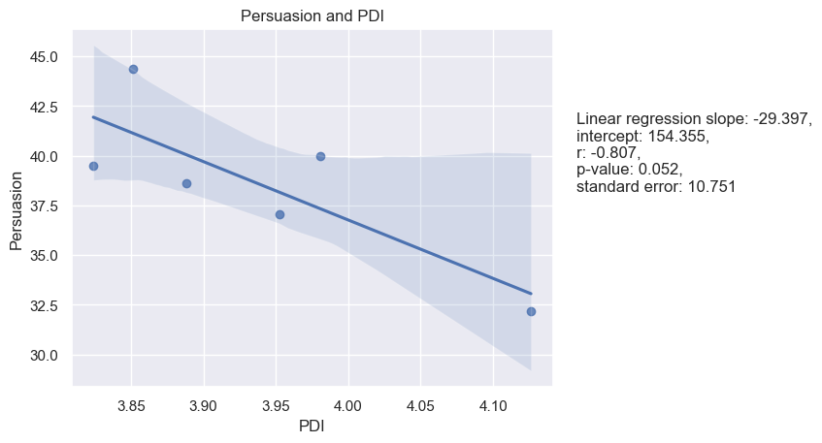

Figure 23. Persuasiveness and Individualism

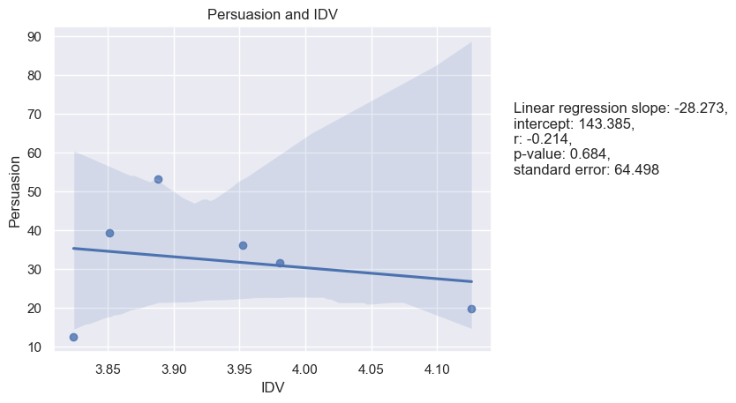

Figure 24. Persuasiveness and Masculinity

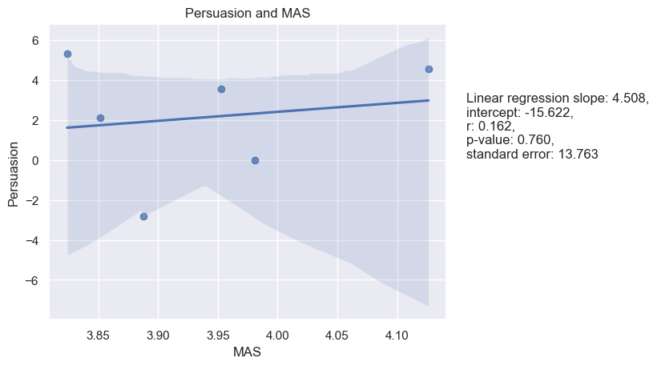

Figure 25. Persuasiveness and Uncertainty Avoidance

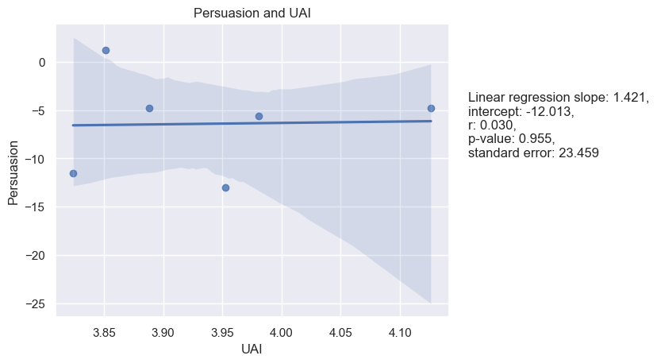

Figure 26. Persuasiveness and Long-Term Orientation

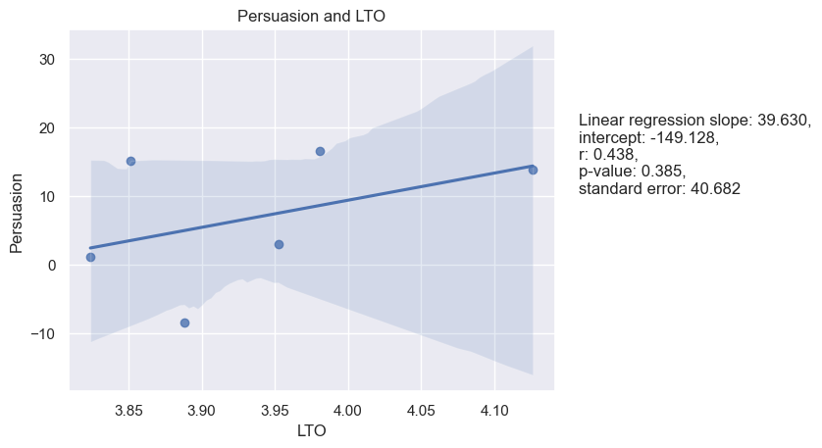

Figure 27. Persuasiveness and Indulgence

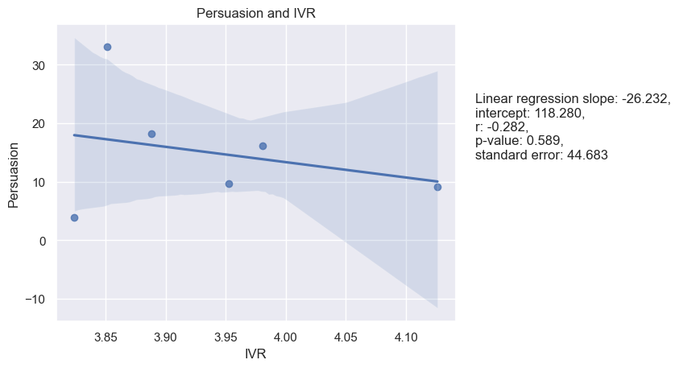

Figure 28. Persuasiveness and Individualism

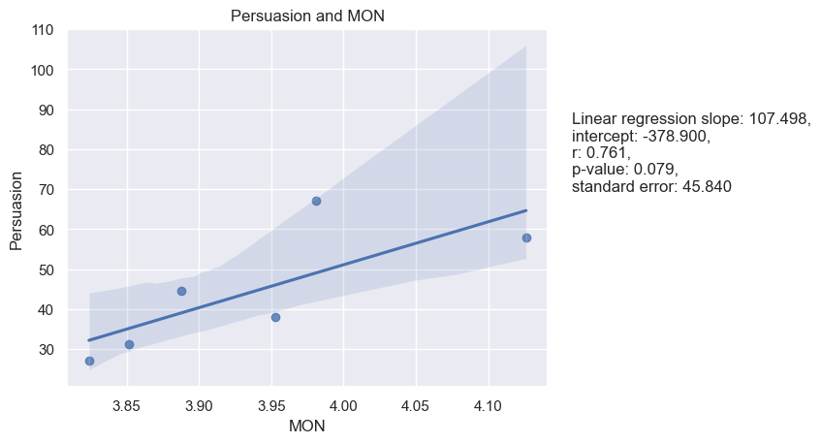

**Initiation of Structure and Hofstede’s dimensions:**

Starting with the non-significant results, the correlation coefficients between Initiation of Structure and PDI, IDV, MAS, UAI, LTO, and IVR are not significant at the 0.05 level. The p-values for these correlations are greater than 0.05, indicating that there is insufficient evidence to conclude that these correlations are statistically significant. However, there is a positive correlation between Initiation of Structure and MON, as shown by both the Pearson (0.82) and Spearman (0.89) correlation coefficients. The linear regression analysis also supports this finding, with a positive slope (144.118) and a positive correlation coefficient (0.819). The p-value for the correlation coefficient is below the 0.05 level, indicating that the relationship is statistically significant. See Table 9.

|  |  |  |  |  |
| --- | --- | --- | --- | --- |
| Table 9. |  | |  | Initiation of Structure |
| Spearman and Pearson Correlations between means of Hofstede’s cultural dimensions and of LBDQ’s Initiation of Structure in six Federal Districts | | Power Distance | Pearson’s r | -0.61 |
| P-value | 0.20 |
| Spearman’s rho | -0.26 |
| P-value | 0.62 |
| Individualism | Pearson’s r | 0.11 |
| P-value | 0.84 |
| Spearman’s rho | 0.09 |
| P-value | 0.87 |
|  | | Masculinity | Pearson’s r | -0.21 |
|  | | P-value | 0.69 |
|  | | Spearman’s rho | -0.37 |
|  | | P-value | 0.47 |
|  | | Uncertainty Avoidance | Pearson’s r | 0.40 |
|  | | P-value | 0.43 |
|  | | Spearman’s rho | 0.54 |
|  | | P-value | 0.27 |
|  | | Long-Term Orientation | Pearson’s r | 0.39 |
|  | | P-value | 0.44 |
|  | | Spearman’s rho | 0.43 |
|  | | P-value | 0.40 |
|  | | Indulgence | Pearson’s r | 0.06 |
|  | | P-value | 0.90 |
|  | | Spearman’s rho | 0.20 |
|  | | P-value | 0.70 |
|  | | Monumentalism | Pearson’s r | 0.82 |
|  | | P-value | 0.05 |
|  | | Spearman’s rho | 0.89 |
|  | | P-value | 0.02 |

Linear regression analysis for the samples as well as a visualization of the regression models are presented below (see figures 29-35):

Figure 29. Initiation of Structure and Power Distance

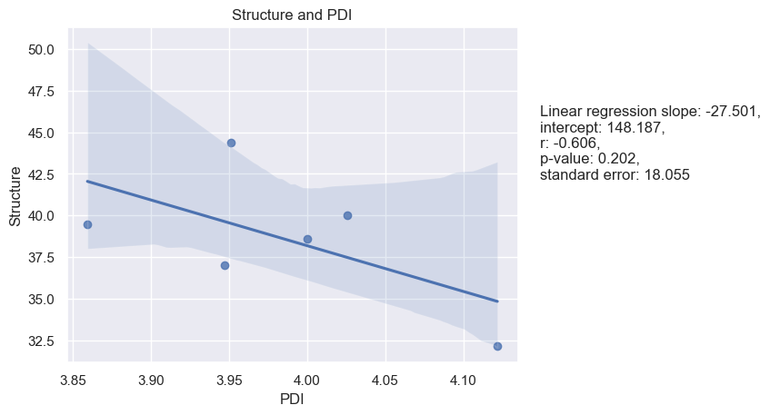

Figure 30. Initiation of Structure and Individualism

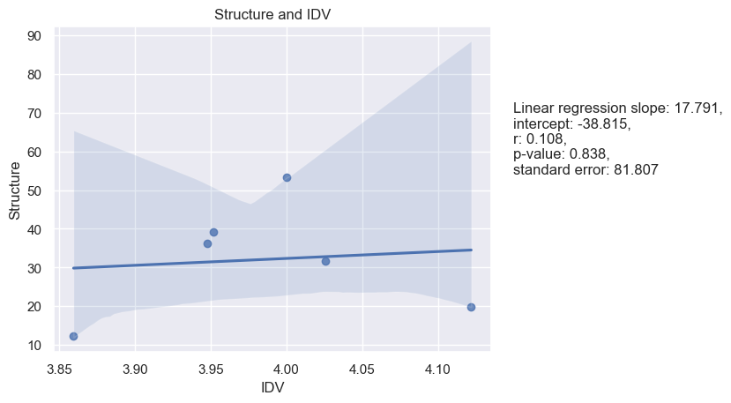

Figure 31. Initiation of Structure and Masculinity

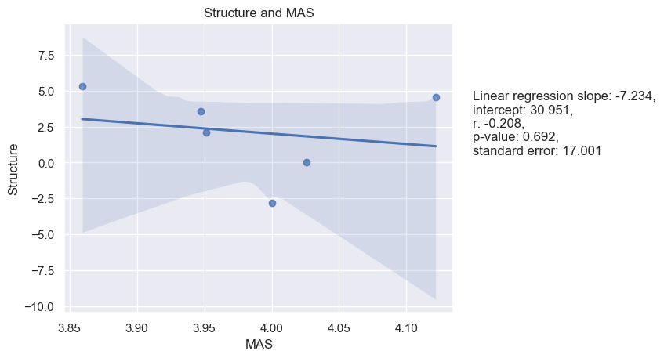

Figure 32. Initiation of Structure and Uncertainty Avoidance

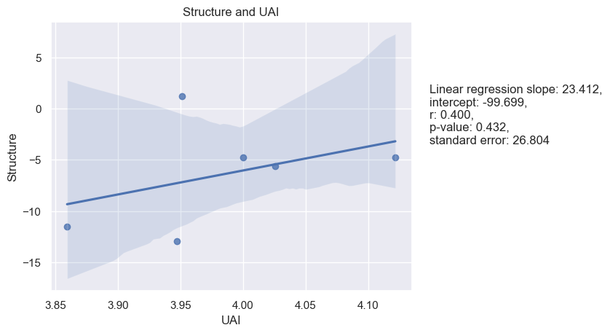

Figure 33. Initiation of Structure and Long-Term Orientation

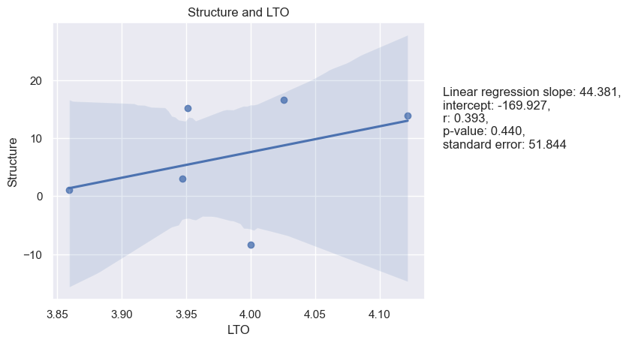

Figure 34. Initiation of Structure and Indulgence

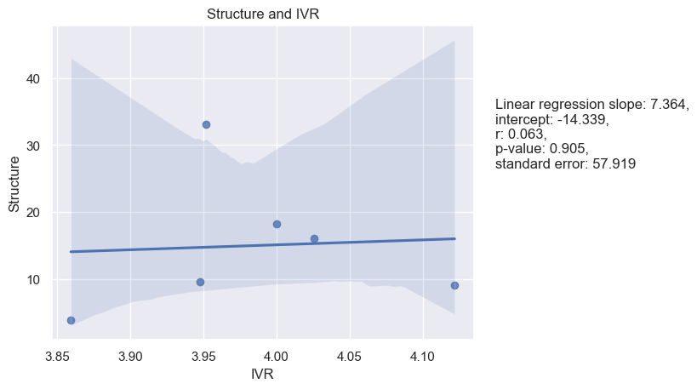

Figure 35. Initiation of Structure and Monumentalism

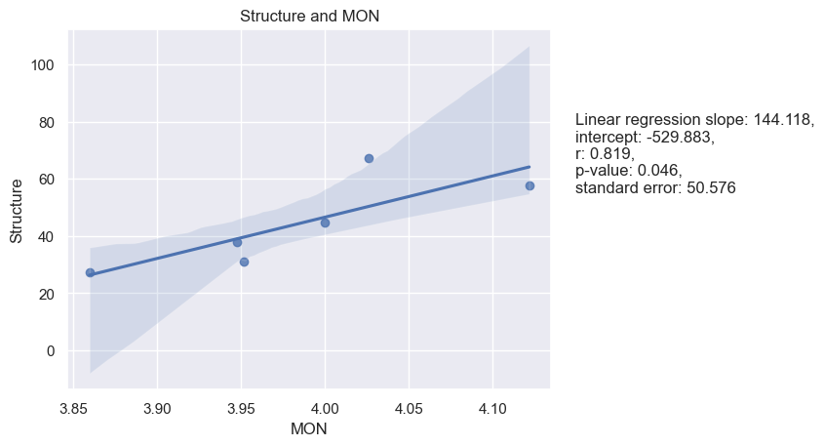

**Tolerance of Freedom and Hofstede’s dimensions**

Based on the provided results, it appears that there are no significant or marginally significant results in the correlations and linear regression analyses between Tolerance and Freedom and any of Hofstede's cultural dimensions. While the lack of significant results may be disappointing, it is important to report both significant and non-significant results to provide a complete and accurate picture of the data analysis. The Pearson correlation coefficients for Tolerance and Freedom and PDI, MAS, UAI, LTO, IVR, and MON are 0.11, 0.07, -0.26, 0.23, -0.38, and 0.33, respectively. See Table 10.

|  |  |  |  |  |
| --- | --- | --- | --- | --- |
| Table 10. |  | |  | Tolerance of Freedom |
| Spearman and Pearson Correlations between means of Hofstede’s cultural dimensions and of LBDQ’s Tolerance of Freedom in six Federal Districts | | Power Distance | Pearson’s r | -0.61 |
| P-value | 0.20 |
| Spearman’s rho | -0.26 |
| P-value | 0.62 |
| Individualism | Pearson’s r | 0.11 |
| P-value | 0.84 |
| Spearman’s rho | 0.09 |
| P-value | 0.87 |
|  | | Masculinity | Pearson’s r | -0.21 |
|  | | P-value | 0.69 |
|  | | Spearman’s rho | -0.37 |
|  | | P-value | 0.47 |
|  | | Uncertainty Avoidance | Pearson’s r | 0.40 |
|  | | P-value | 0.43 |
|  | | Spearman’s rho | 0.54 |
|  | | P-value | 0.27 |
|  | | Long-Term Orientation | Pearson’s r | 0.39 |
|  | | P-value | 0.44 |
|  | | Spearman’s rho | 0.43 |
|  | | P-value | 0.40 |
|  | | Indulgence | Pearson’s r | 0.06 |
|  | | P-value | 0.90 |
|  | | Spearman’s rho | 0.20 |
|  | | P-value | 0.70 |
|  | | Monumentalism | Pearson’s r | 0.82 |
|  | | P-value | 0.05 |
|  | | Spearman’s rho | 0.89 |
|  | | P-value | 0.02 |

Linear regression analysis was performed as well. See Figures 36-42:

Figure 36. Tolerance of Freedom and Power Distance

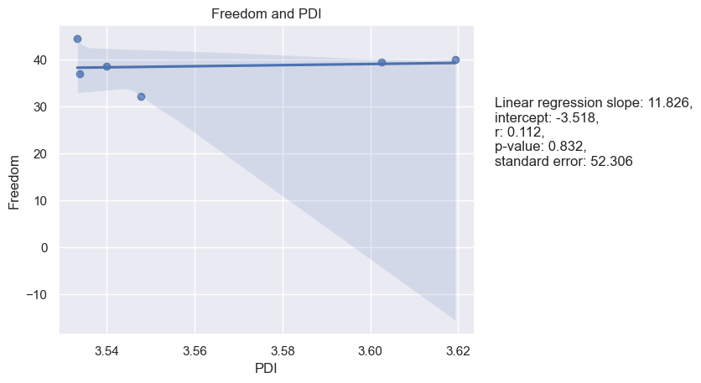

Figure 37. Tolerance of Freedom and Individualism

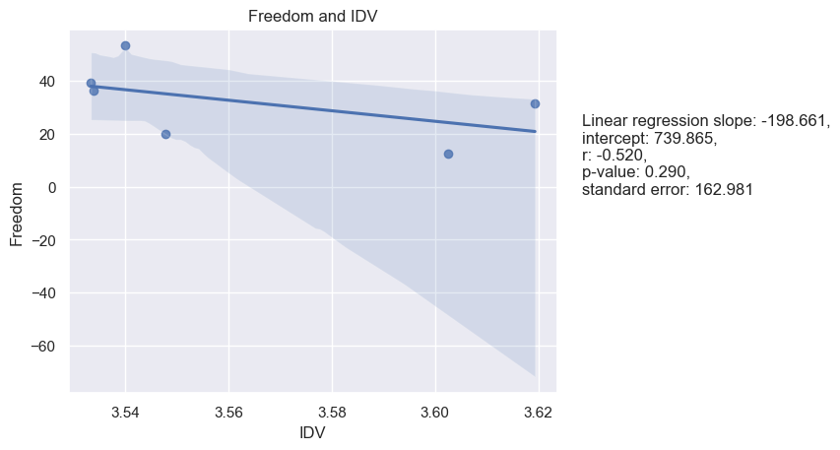

Figure 38. Tolerance of Freedom and Masculinity

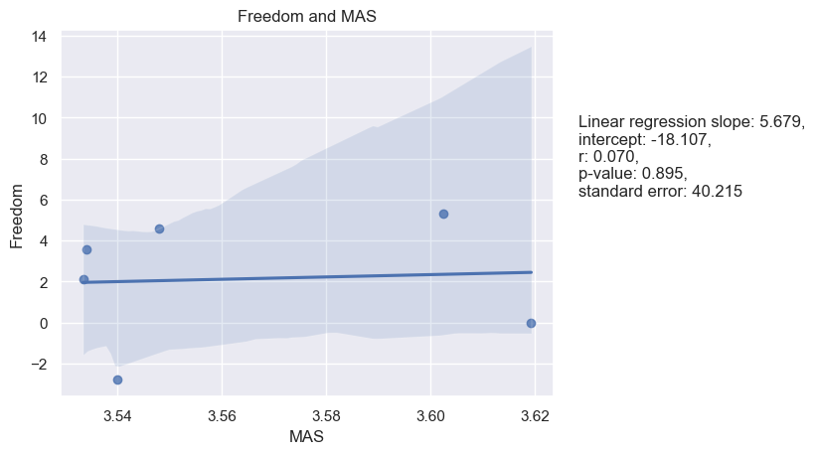

Figure 39. Tolerance of Freedom and Uncertainty Avoidance

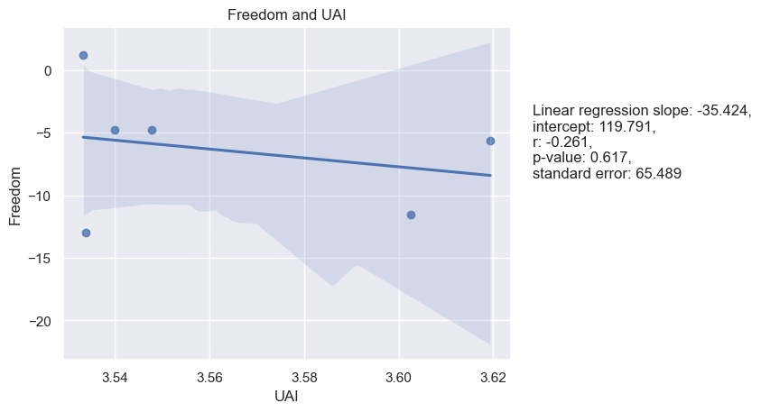

Figure 40. Tolerance of Freedom and Long-Term Orientation

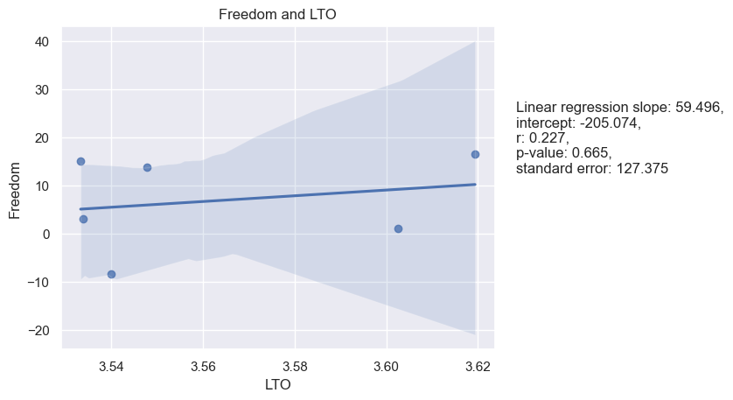

Figure 41. Tolerance of Freedom and Indulgence

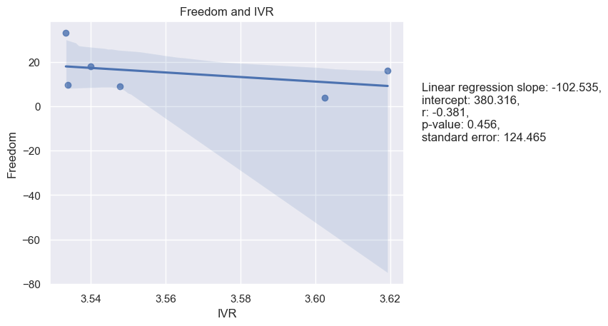

Figure 42. Tolerance of Freedom and Indulgence

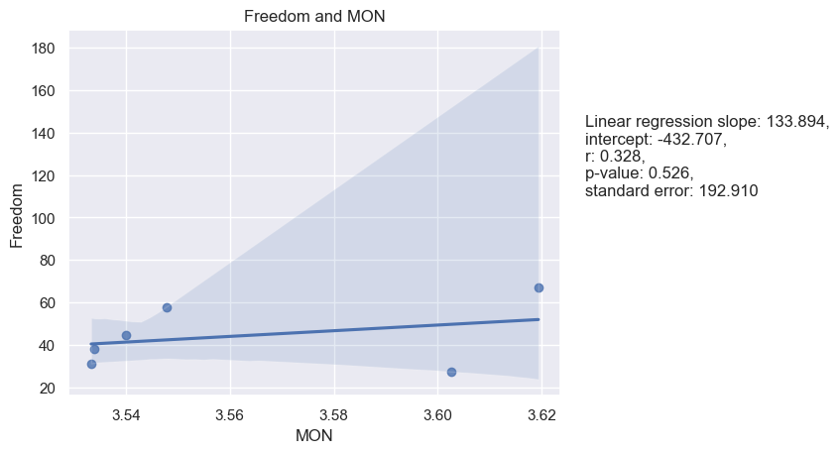

**Role assumption and Hofstede’s dimensions**

The results of the Pearson and Spearman correlation tests, as well as the linear regression analysis, indicate that there are no statistically significant relationships between the Role Assumption dimension of LBDQ and Hofstede's cultural dimensions, except for a marginally significant negative correlation with PDI (Pearson: -0.57, P-val: 0.24; Spearman: -0.37, P-val: 0.47) and a marginally significant positive correlation with MON (Pearson: 0.57, P-val: 0.24; Spearman: 0.77, P-val: 0.07). See table 11.

|  |  |  |  |  |
| --- | --- | --- | --- | --- |
| Table 11. |  | |  | Role Assumption |
| Spearman and Pearson Correlations between means of Hofstede’s cultural dimensions and of LBDQ’s Role Assumption in six Federal Districts | | Power Distance | Pearson’s r | -0.57 |
| P-value | 0.24 |
| Spearman’s rho | -0.37 |
| P-value | 0.47 |
| Individualism | Pearson’s r | 0.37 |
| P-value | 0.47 |
| Spearman’s rho | 0.26 |
| P-value | 0.62 |
|  | | Masculinity | Pearson’s r | -0.41 |
|  | | P-value | 0.42 |
|  | | Spearman’s rho | -0.43 |
|  | | P-value | 0.40 |
|  | | Uncertainty Avoidance | Pearson’s r | 0.42 |
|  | | P-value | 0.41 |
|  | | Spearman’s rho | 0.60 |
|  | | P-value | 0.21 |
|  | | Long-Term Orientation | Pearson’s r | -0.04 |
|  | | P-value | 0.95 |
|  | | Spearman’s rho | 0.14 |
|  | | P-value | 0.79 |
|  | | Indulgence | Pearson’s r | 0.12 |
|  | | P-value | 0.82 |
|  | | Spearman’s rho | 0.26 |
|  | | P-value | 0.62 |
|  | | Monumentalism | Pearson’s r | 0.57 |
|  | | P-value | 0.24 |
|  | | Spearman’s rho | 0.77 |
|  | | P-value | 0.07 |

In addition to both Spearman and Pearson correlations, linear regression was also performed. See Figures 43-49.

Figure 43. Role Assumption and Power Distance

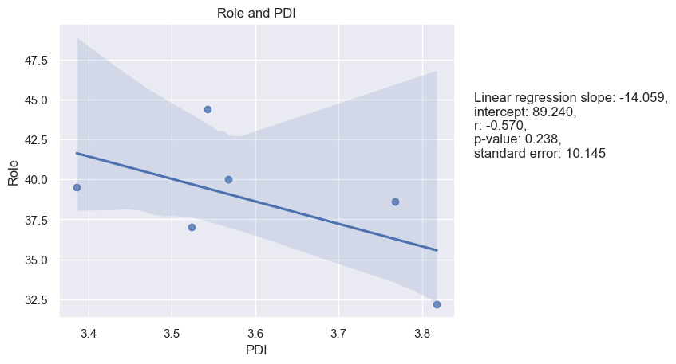

Figure 44. Role Assumption and Individualism

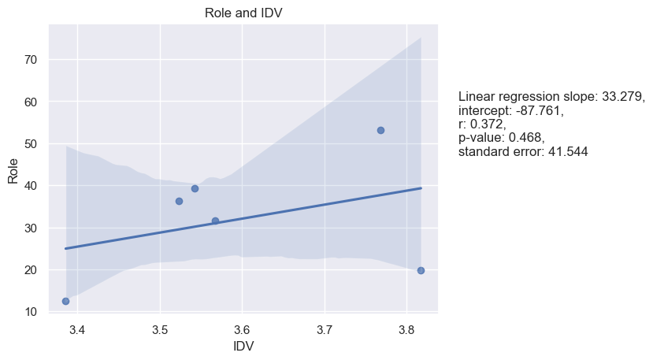

Figure 45. Role Assumption and Masculinity

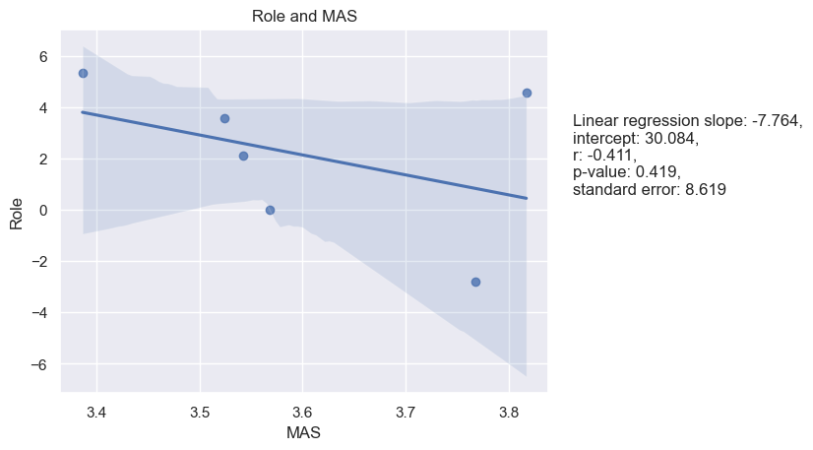

Figure 46. Role Assumption and Uncertainty Avoidance

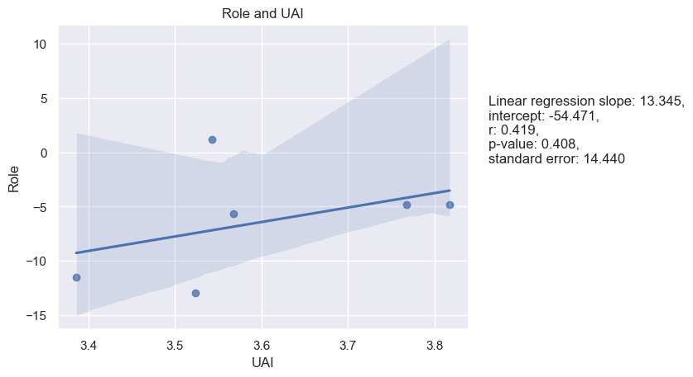

Figure 47. Role Assumption and Long-Term Orientation

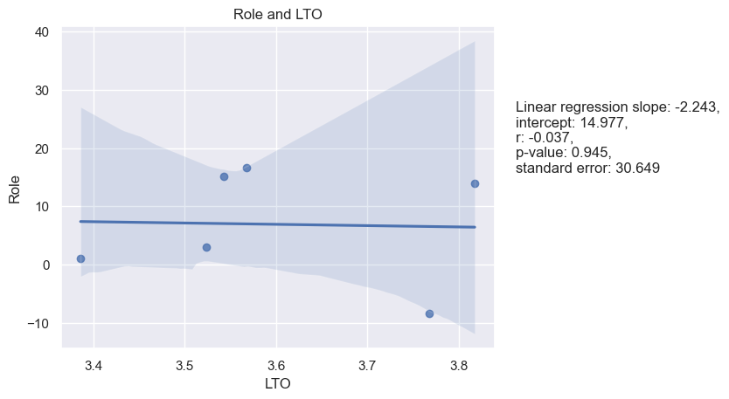

Figure 48. Role Assumption and Indulgence

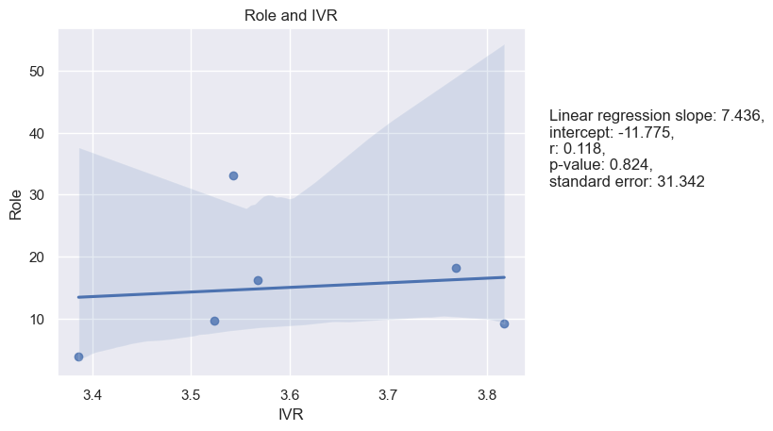

Figure 49. Role Assumption and Monumentalism

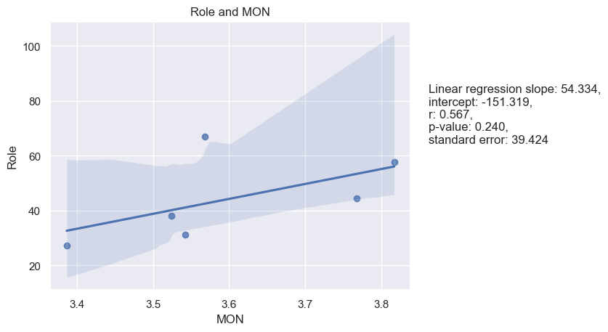

**Consideration and Hofstede’s dimensions**

There is a positive correlation between Consideration and UAI, with a Pearson correlation of 0.75 and a Spearman correlation of 0.83 with p-values of 0.09 and 0.04 accrodingly. The linear regression slope is positive (47.133), indicating that as UAI increases, so does Consideration. The p-value for the linear regression is 0.086, which is marginally significant. This suggests that there may be some relationship between a leader's Consideration and a culture's level of uncertainty avoidance, although further investigation is needed to determine the nature of this relationship. However, the analysis shows that there is no significant correlation or regression between Consideration and PDI, IDV, MAS, LTO, IVR, and MON dimensions. See Table 12.

|  |  |  |  |  |
| --- | --- | --- | --- | --- |
| Table 12. |  | |  | Consideration |
| Spearman and Pearson Correlations between means of Hofstede’s cultural dimensions and of LBDQ’s Consideration in six Federal Districts | | Power Distance | Pearson’s r | -0.08 |
| P-value | 0.87 |
| Spearman’s rho | -0.03 |
| P-value | 0.96 |
| Individualism | Pearson’s r | 0.29 |
| P-value | 0.58 |
| Spearman’s rho | 0.14 |
| P-value | 0.79 |
|  | | Masculinity | Pearson’s r | -0.24 |
|  | | P-value | 0.65 |
|  | | Spearman’s rho | -0.20 |
|  | | P-value | 0.70 |
|  | | Uncertainty Avoidance | Pearson’s r | 0.75 |
|  | | P-value | 0.09 |
|  | | Spearman’s rho | 0.83 |
|  | | P-value | 0.04 |
|  | | Long-Term Orientation | Pearson’s r | 0.67 |
|  | | P-value | 0.15 |
|  | | Spearman’s rho | 0.60 |
|  | | P-value | 0.21 |
|  | | Indulgence | Pearson’s r | 0.59 |
|  | | P-value | 0.22 |
|  | | Spearman’s rho | 0.37 |
|  | | P-value | 0.47 |
|  | | Monumentalism | Pearson’s r | 0.58 |
|  | | P-value | 0.23 |
|  | | Spearman’s rho | 0.54 |
|  | | P-value | 0.27 |

Linear regression analysis for the samples as well as a visualization of the regression models are presented below (see figures 50-56):

Figure 50. Consideration and Power Distance

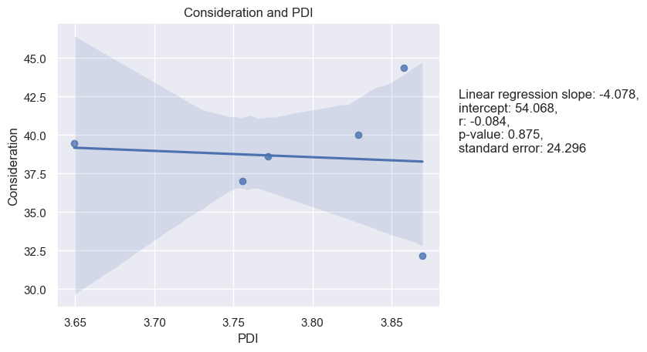

Figure 51. Consideration and Individualism

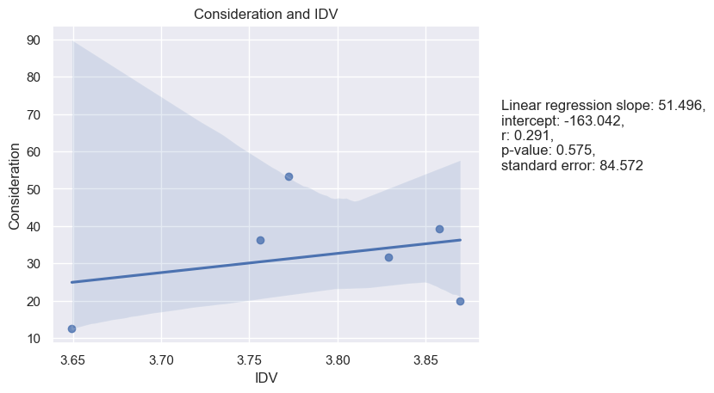

Figure 52. Consideration and Masculinity

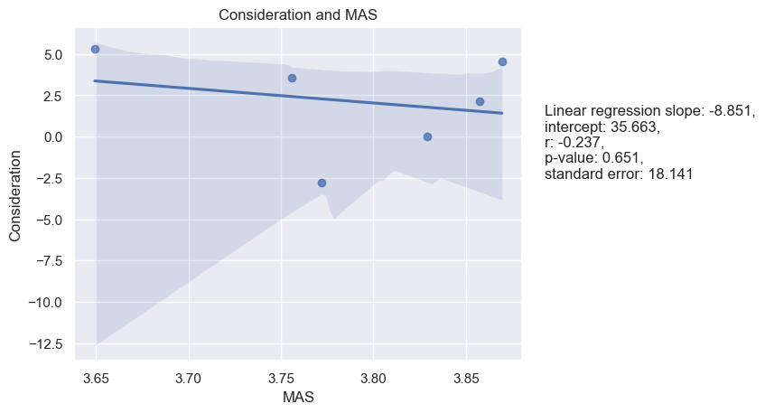

Figure 53. Consideration and Uncertainty Avoidance

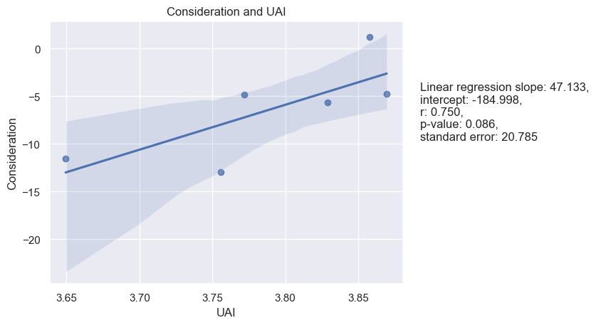

Figure 54. Consideration and Long-Term Orientation

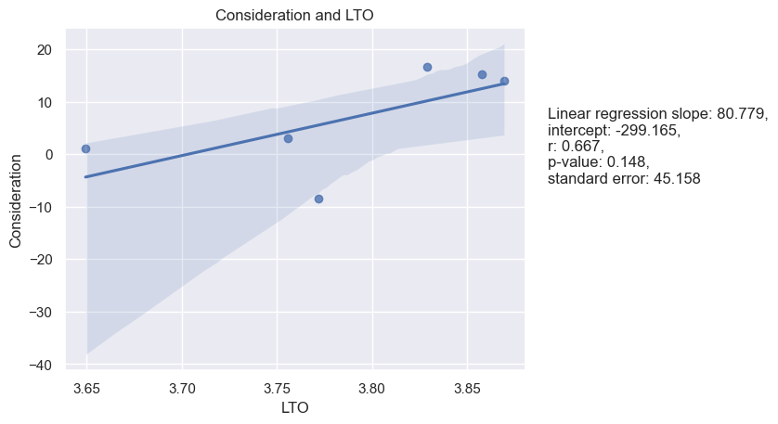

Figure 55. Consideration and Indulgence

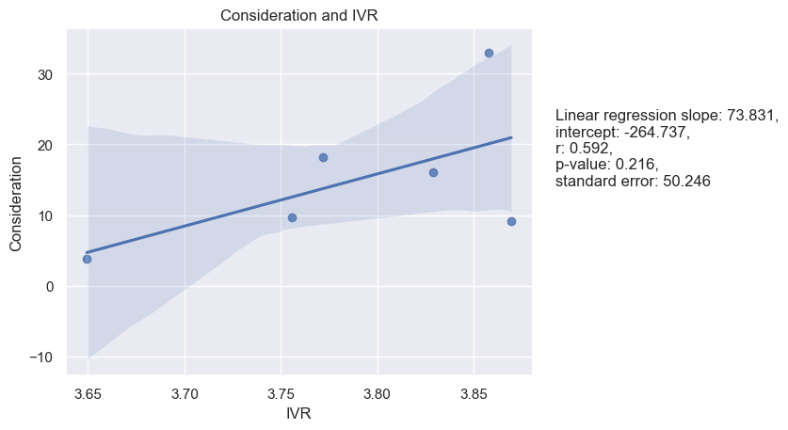

Figure 56. Consideration and Monumentalism

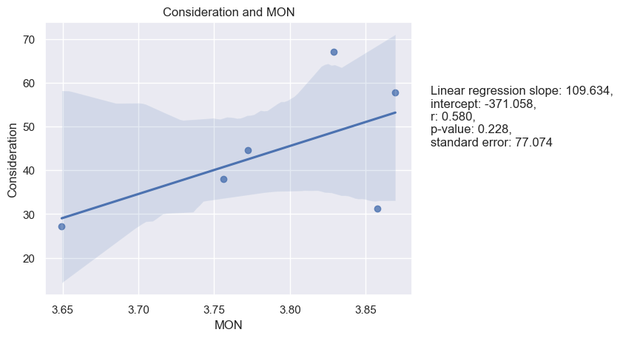

**Production Emphasis and Hofstede’s dimensions**

Production Emphasis and LTO have a Pearson correlation coefficient of 0.83 with a p-value of 0.04, indicating a strong positive correlation between the two variables. The Spearman correlation coefficient is also positive at 0.71, although the p-value is not significant at 0.11. The linear regression model has a slope of 142.819 and an intercept of -516.951. The r value of 0.834 indicates a strong positive correlation, and the p-value of 0.039 is significant. There were no significant relationships found between Production Emphasis and PDI, IDV, MAS, UAI, IVR, and MON. See Table 13.

|  |  |  |  |  |
| --- | --- | --- | --- | --- |
| Table 13. |  | |  | Production Emphasis |
| Spearman and Pearson Correlations between means of Hofstede’s cultural dimensions and of LBDQ’s Production Emphasis in six Federal Districts | | Power Distance | Pearson’s r | -0.35 |
| P-value | 0.50 |
| Spearman’s rho | -0.31 |
| P-value | 0.54 |
| Individualism | Pearson’s r | -0.62 |
| P-value | 0.19 |
| Spearman’s rho | -0.43 |
| P-value | 0.40 |
|  | | Masculinity | Pearson’s r | -0.63 |
|  | | P-value | 0.18 |
|  | | Spearman’s rho | 0.26 |
|  | | P-value | 0.62 |
|  | | Uncertainty Avoidance | Pearson’s r | -0.06 |
|  | | P-value | 0.90 |
|  | | Spearman’s rho | 0.09 |
|  | | P-value | 0.87 |
|  | | Long-Term Orientation | Pearson’s r | 0.83 |
|  | | P-value | 0.04 |
|  | | Spearman’s rho | 0.71 |
|  | | P-value | 0.11 |
|  | | Indulgence | Pearson’s r | -0.20 |
|  | | P-value | 0.70 |
|  | | Spearman’s rho | -0.26 |
|  | | P-value | 0.62 |
|  | | Monumentalism | Pearson’s r | 0.41 |
|  | | P-value | 0.42 |
|  | | Spearman’s rho | 0.60 |
|  | | P-value | 0.21 |

Linear regression analysis was performed as well. See Figures 57-63:

Figure 57. Production Emphasis and Power Distance

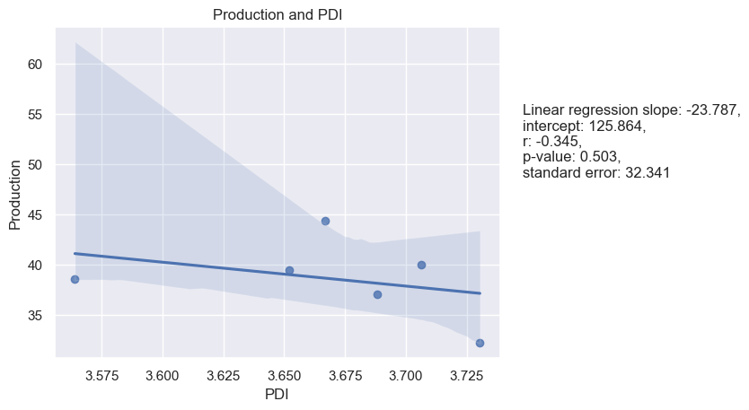

Figure 58. Production Emphasis and Individualism

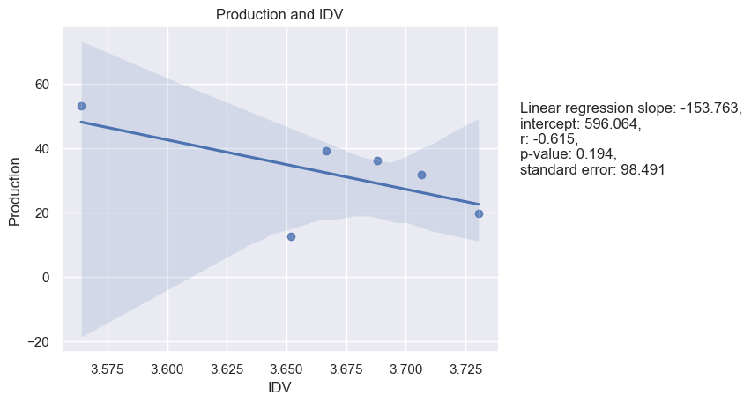

Figure 59. Production Emphasis and Masculinity

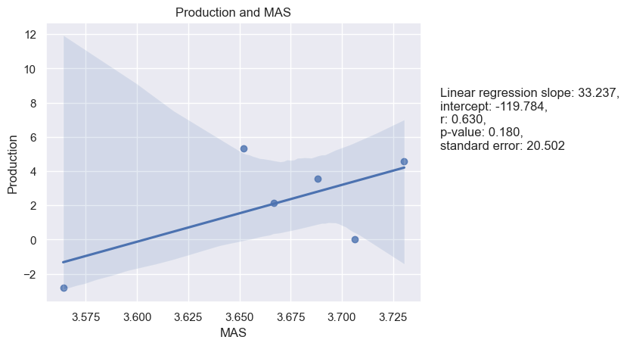

Figure 60. Production Emphasis and Uncertainty Avoidance

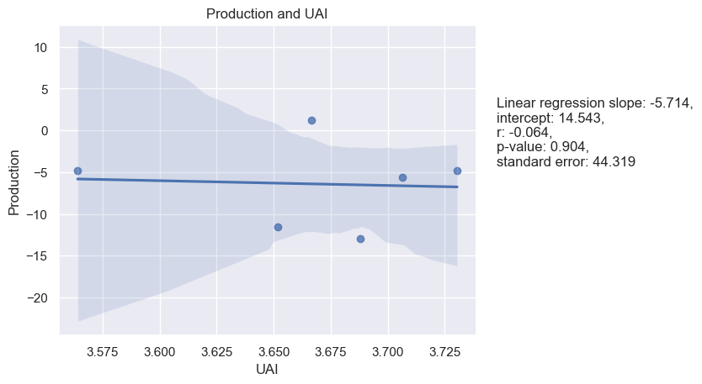

Figure 61. Production Emphasis and Long-Term Orientation

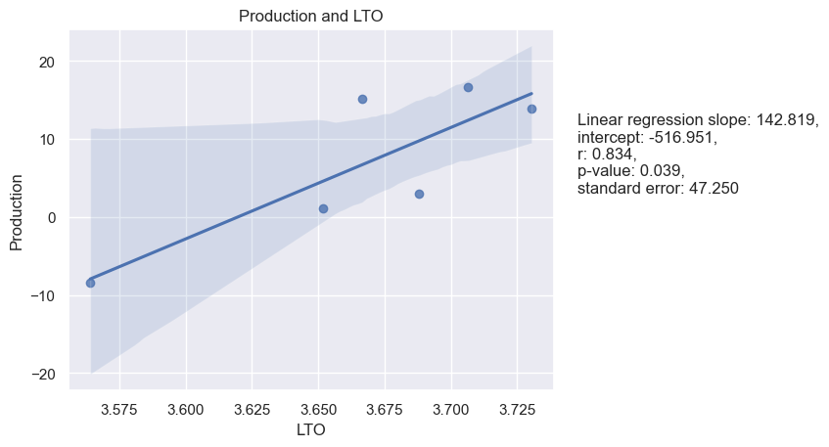

Figure 62. Production Emphasis and Indulgence

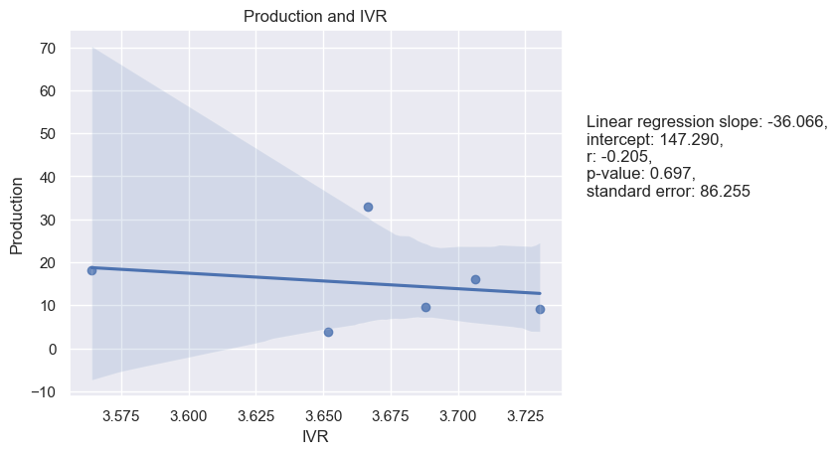

Figure 63. Production Emphasis and Monumentalism

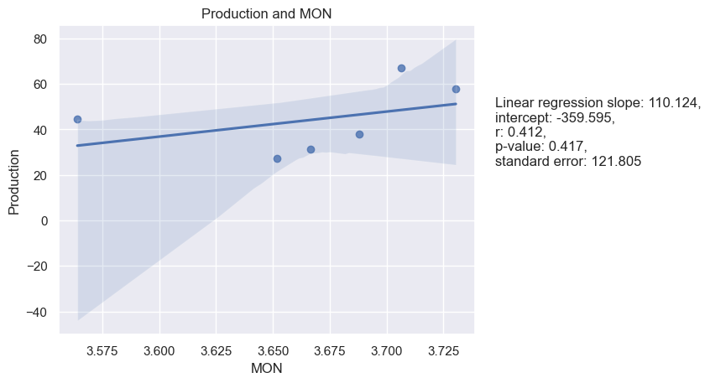

**Prediction Accuracy and Hofstede’s dimensions**

Based on the given results, we can see that the correlations between predictive accuracy and most of Hofstede's cultural dimensions are not statistically significant, with p-values greater than 0.05. However, there is a significant correlation between predictive accuracy and MAS with a Pearson correlation of -0.90 and a p-value of 0.01, as well as a Spearman correlation of -0.83 and a p-value of 0.04. The linear regression model also shows a significant negative relationship between these two variables, with a slope of -30.331 and an intercept of 118.795. See Table 14.

|  |  |  |  |  |
| --- | --- | --- | --- | --- |
| Table 14. |  | |  | Prediction Accuracy |
| Spearman and Pearson Correlations between means of Hofstede’s cultural dimensions and of LBDQ’s Prediction Accuracy in six Federal Districts | | Power Distance | Pearson’s r | 0.07 |
| P-value | 0.90 |
| Spearman’s rho | -0.03 |
| P-value | 0.96 |
| Individualism | Pearson’s r | 0.69 |
| P-value | 0.13 |
| Spearman’s rho | 0.54 |
| P-value | 0.27 |
|  | | Masculinity | Pearson’s r | -0.90 |
|  | | P-value | 0.01 |
|  | | Spearman’s rho | -0.73 |
|  | | P-value | 0.04 |
|  | | Uncertainty Avoidance | Pearson’s r | 0.56 |
|  | | P-value | 0.25 |
|  | | Spearman’s rho | 0.43 |
|  | | P-value | 0.40 |
|  | | Long-Term Orientation | Pearson’s r | 0.02 |
|  | | P-value | 0.98 |
|  | | Spearman’s rho | 0.09 |
|  | | P-value | 0.87 |
|  | | Indulgence | Pearson’s r | 0.47 |
|  | | P-value | 0.35 |
|  | | Spearman’s rho | 0.54 |
|  | | P-value | 0.27 |
|  | | Monumentalism | Pearson’s r | 0.66 |
|  | | P-value | 0.16 |
|  | | Spearman’s rho | 0.77 |
|  | | P-value | 0.07 |

Linear regression analysis for the samples as well as a visualization of the regression models are presented below (see figures 64-70):

Figure 64. Prediction Accuracy and Power Distance

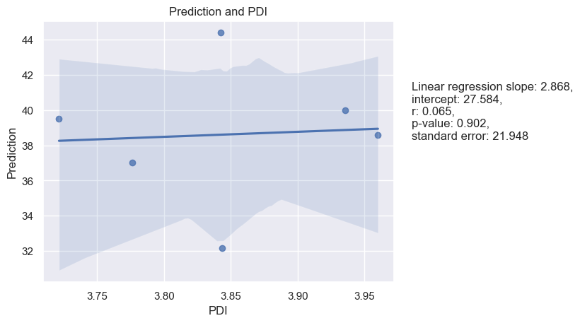

Figure 65. Prediction Accuracy and Individualism

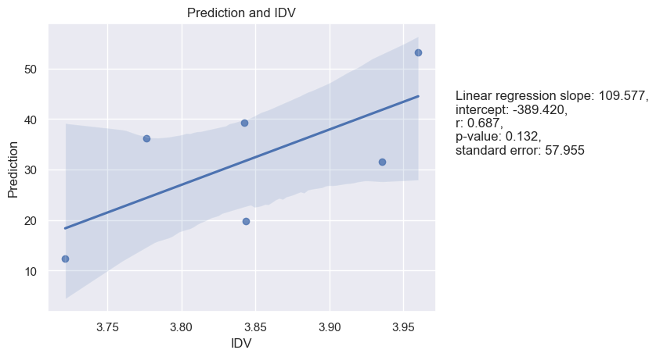

Figure 66. Prediction Accuracy and Masculinity

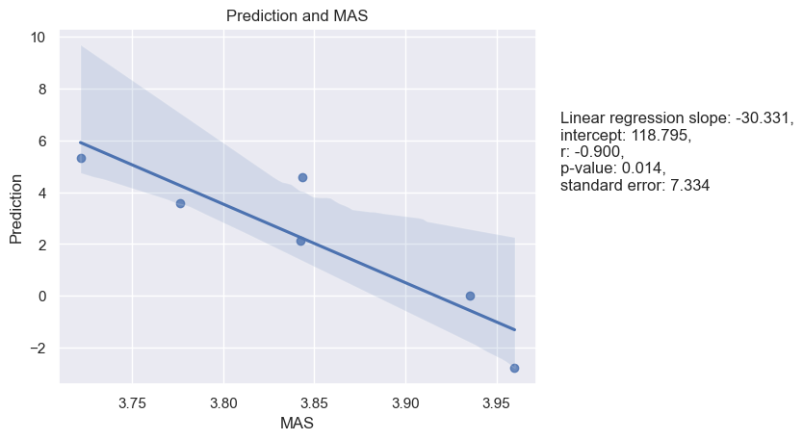

Figure 67. Prediction Accuracy and Uncertainty Avoidance

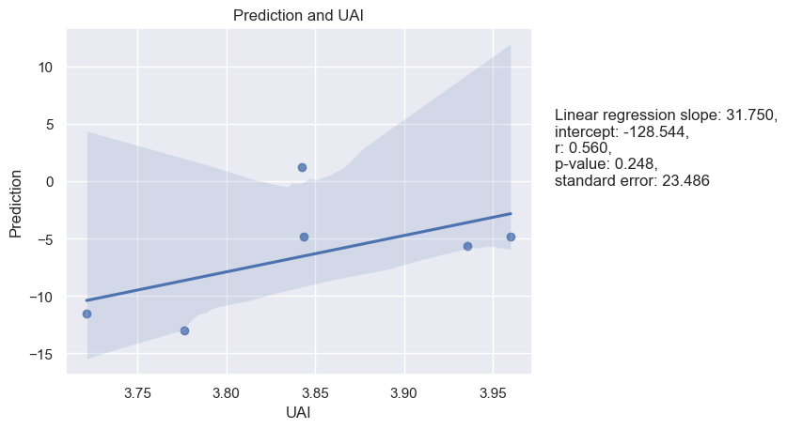

Figure 68. Prediction Accuracy and Long-Term Orientation.

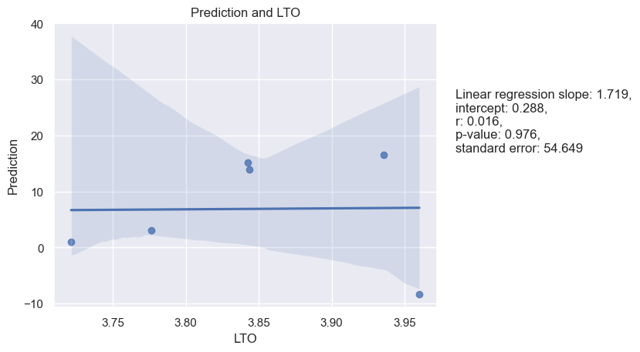

Figure 69. Prediction Accuracy and Indulgence

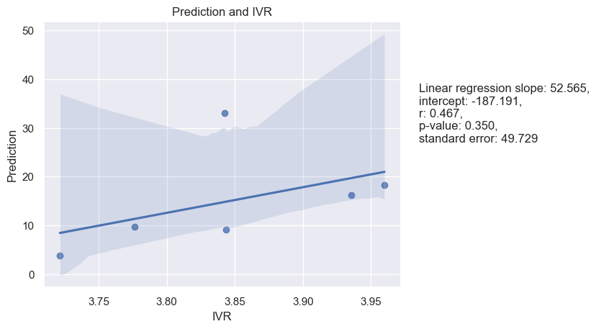

Figure 70. Prediction Accuracy and Monumentalism

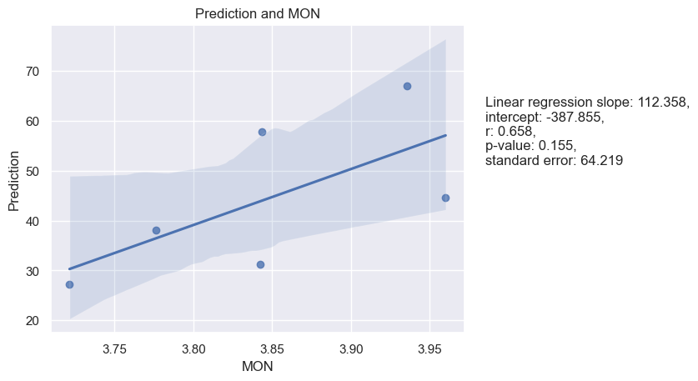

**Integration and Hofstede’s dimensions**

The correlation analysis shows that there is a significant negative correlation between Integration and MON (Pearson r = -0.86, p = 0.03; Spearman rho = 0.94, p = 0.00). This indicates that as the Integration of a leader increases, the Masculinity of the culture decreases, i.e., the culture becomes more feminine. The linear regression model also confirms this relationship as the regression slope is negative and statistically significant (slope = 92.548, p = 0.027). However, the relationship between Integration and IDV, UAI, IVR, PDI, LTO and MAS are not significant. See Table 15.

|  |  |  |  |  |
| --- | --- | --- | --- | --- |
| Table 15. |  | |  | Integration |
| Spearman and Pearson Correlations between means of Hofstede’s cultural dimensions and of LBDQ’s Integration in six Federal Districts | | Power Distance | Pearson’s r | -0.68 |
| P-value | 0.14 |
| Spearman’s rho | -0.49 |
| P-value | 0.33 |
| Individualism | Pearson’s r | -0.18 |
| P-value | 0.73 |
| Spearman’s rho | 0.03 |
| P-value | 0.96 |
|  | | Masculinity | Pearson’s r | 0.02 |
|  | | P-value | 0.97 |
|  | | Spearman’s rho | -0.31 |
|  | | P-value | 0.54 |
|  | | Uncertainty Avoidance | Pearson’s r | 0.23 |
|  | | P-value | 0.66 |
|  | | Spearman’s rho | 0.26 |
|  | | P-value | 0.62 |
|  | | Long-Term Orientation | Pearson’s r | 0.53 |
|  | | P-value | 0.28 |
|  | | Spearman’s rho | 0.31 |
|  | | P-value | 0.54 |
|  | | Indulgence | Pearson’s r | -0.15 |
|  | | P-value | 0.78 |
|  | | Spearman’s rho | 0.03 |
|  | | P-value | 0.96 |
|  | | Monumentalism | Pearson’s r | 0.86 |
|  | | P-value | 0.03 |
|  | | Spearman’s rho | 0.94 |
|  | | P-value | 0.00 |

Linear regression analysis as well as its representation are presented below. See Figures 71-77.

Figure 71. Integration and Power Distance.

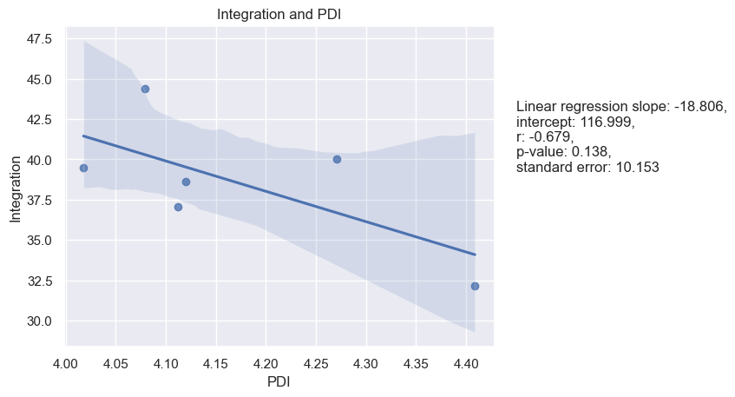

Figure 72. Integration and Individualism

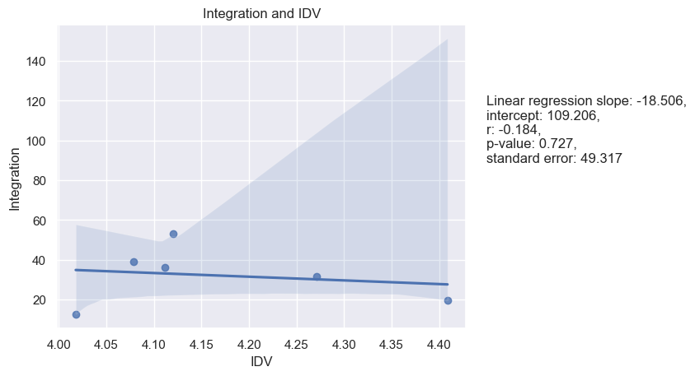

Figure 73. Integration and Masculinity

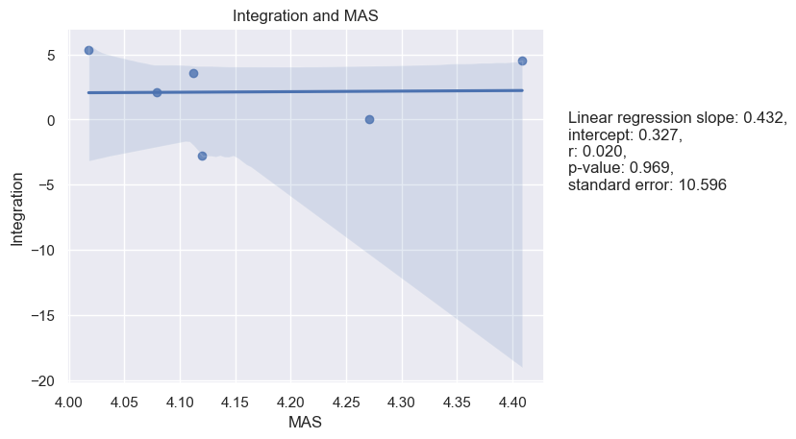

Figure 74. Integration and Uncertainty Avoidance

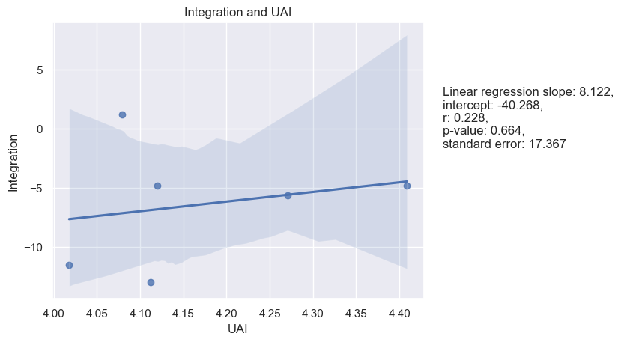

Figure 75. Integration and Long-Term Orientation

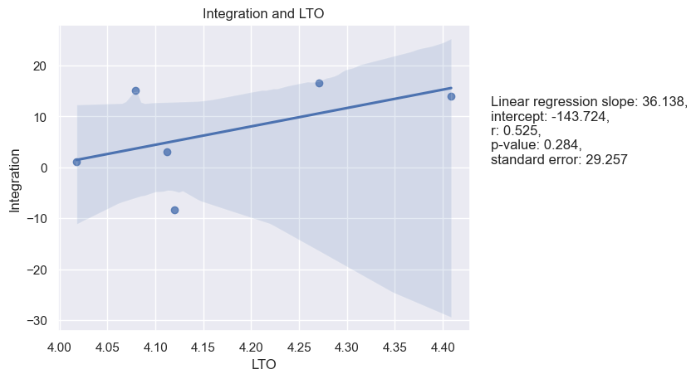

Figure 76. Integration and Indulgence

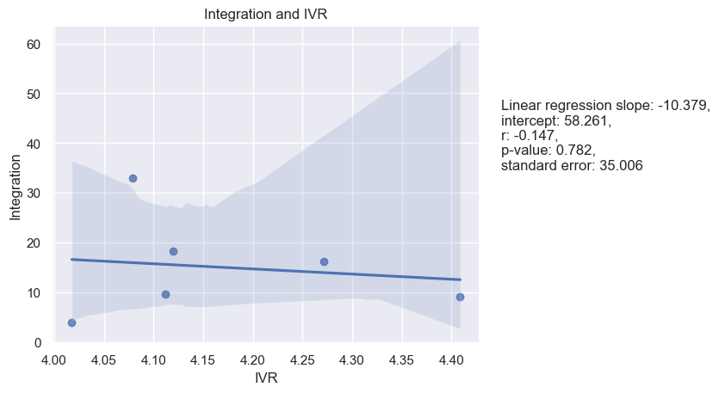

Figure 77. Integration and Monumentalism

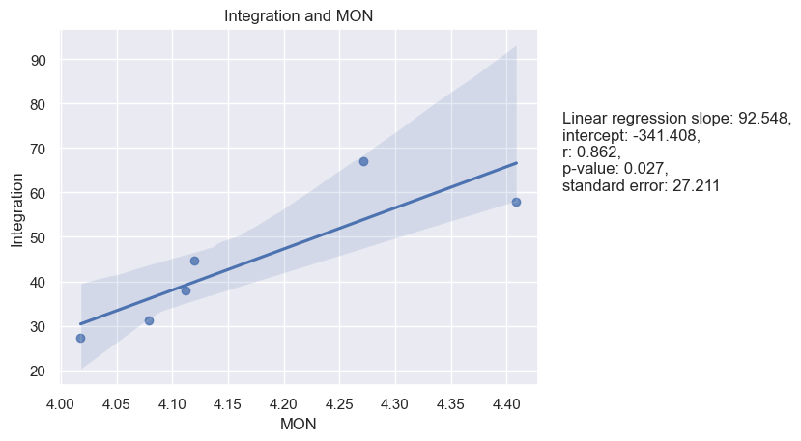

**Superior Orientation and Hofstede’s dimensions**

Based on the provided results, it seems that there are no statistically significant relationships between Superior Orientation and Hofstede's cultural dimensions, as all p-values are greater than the commonly accepted significance level of 0.05. See Table 16.

|  |  |  |  |  |
| --- | --- | --- | --- | --- |
| Table 16. |  | |  | Superior Orientation |
| Spearman and Pearson Correlations between means of Hofstede’s cultural dimensions and of LBDQ’s Superior Orientation in six Federal Districts | | Power Distance | Pearson’s r | -0.60 |
| P-value | 0.21 |
| Spearman’s rho | -0.71 |
| P-value | 0.11 |
| Individualism | Pearson’s r | 0.38 |
| P-value | 0.45 |
| Spearman’s rho | 0.37 |
| P-value | 0.47 |
|  | | Masculinity | Pearson’s r | -0.51 |
|  | | P-value | 0.30 |
|  | | Spearman’s rho | -0.37 |
|  | | P-value | 0.47 |
|  | | Uncertainty Avoidance | Pearson’s r | -0.32 |
|  | | P-value | 0.54 |
|  | | Spearman’s rho | -0.31 |
|  | | P-value | 0.54 |
|  | | Long-Term Orientation | Pearson’s r | -0.58 |
|  | | P-value | 0.23 |
|  | | Spearman’s rho | -0.54 |
|  | | P-value | 0.27 |
|  | | Indulgence | Pearson’s r | -0.40 |
|  | | P-value | 0.43 |
|  | | Spearman’s rho | -0.03 |
|  | | P-value | 0.96 |
|  | | Monumentalism | Pearson’s r | 0.46 |
|  | | P-value | 0.35 |
|  | | Spearman’s rho | 0.43 |
|  | | P-value | 0.40 |

Linear regression analysis was utilized for the samples as well as a visualization of the regression models was performed to better understand the results (see figures 78-84):

Figure 78. Superior Orientation and Power Distance

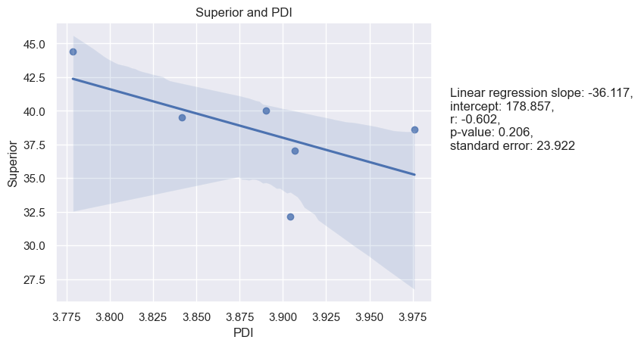

Figure 79. Superior Orientation and Individualism

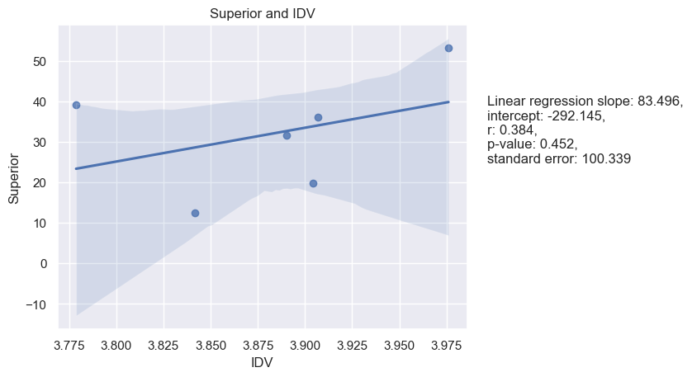

Figure 80. Superior Orientation and Masculinity

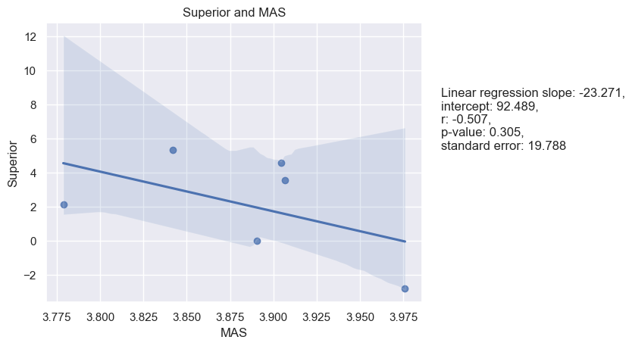

Figure 81. Superior Orientation and Uncertainty Avoidance

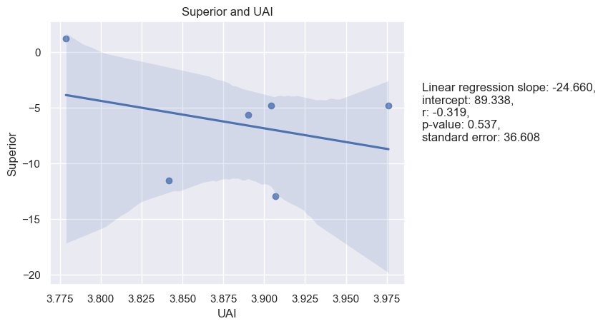

Figure 82. Superior Orientation and Long-Term Orientation

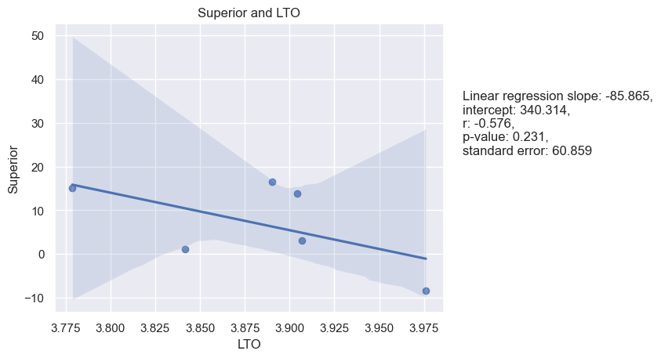

Figure 83. Superior Orientation and Indulgence

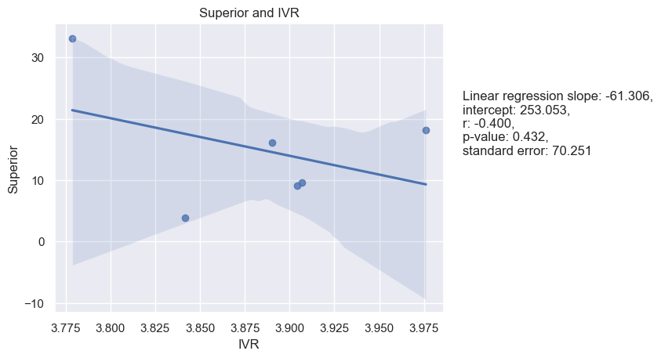

Figure 83. Superior Orientation and Indulgence

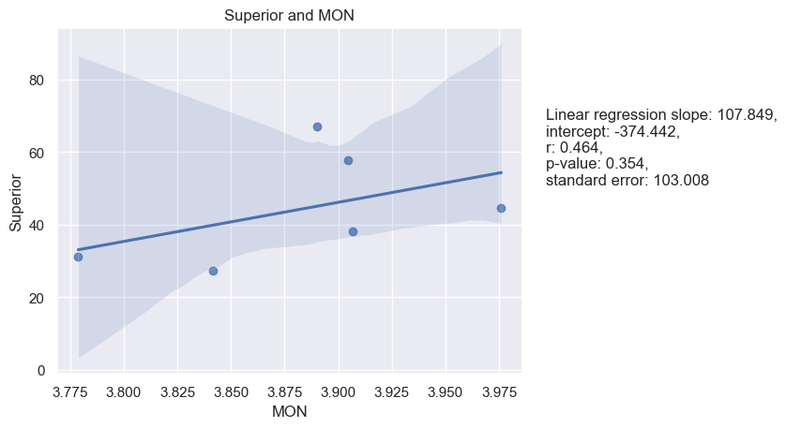

As previously mentioned, the samples used in the analysis were constrained to certain federal districts of Russia due to the limited number of responses received. This could introduce some degree of randomness to the results. However, the study still offers valuable insights into the correlation between cultural values and leader behavior preferences across various regions of Russia. It is important to note that the results presented in Table 17 and Table 18 are applicable to the entire sample of respondents from Russia, and not just the selected six federal districts that were the focus of the analysis.

|  |  |  |  |
| --- | --- | --- | --- |
| Table 17. |  | | Mean Score / Russia |
| Mean scores for Hofstede’s dimensions in overall sample in Russia | | Power Distance | 43.3 |
| Individualism | 32.1 |
| Masculinity | 4.9 |
| Uncertainty Avoidance | -11.4 |
| Long-Term Orientation | 9.0 |
| Indulgence | 9.9 |
| Monumentalism | 44.2 |

|  |  |  |  |
| --- | --- | --- | --- |
| Table 18. |  | | Mean Score / Russia |
| Mean scores for LBDQ’s dimensions in overall sample in Russia | | Representation | 3.7 |
| Reconciliation | 3.7 |
| Tolerance of Uncertainty | 3.4 |
| Persuasiveness | 3.9 |
| Initiation of Structure | 4.0 |
| Tolerance of Freedom | 3.5 |
| Role Assumption | 3.7 |
|  | | Consideration | 3.7 |
|  | | Production Emphasis | 3.7 |
|  | | Prediction Accuracy | 3.9 |
|  | | Integration | 4.1 |
|  | | Superior Orientation | 3.9 |